The use of flow meter for monitoring fuel oil consumption in a tugboat owned by
pt. Nusantara Terminal Terpadu

Danny Faturachman¹⁾, Muswar Muslim²⁾, Achmad Djaeni³⁾, Benny Cahyono⁴⁾, Agoes Santoso⁵⁾
^{1), 2)} Dosen Jurusan Teknik Sistem Perkaplaan, Faklutas Teknologi kelautan, UNSADA, Jakarta
³⁾ Karyawan PT. Nusantara Terminal Terpadu, dan Mahasiswa Faklutas Teknologi Kelautan UNSADA, Jakarta
^{4), 5)} Dosen Jurusan Siskal, Fakultas Teknologi kelautan, ITS Surabaya

ABSTRACT
Many ships are not furnished with an apparatus to bosun and crew of a ship will be able to measure and monitor the use of fuel when the ship sailing. A system in a ship must include the ability to monitoring the fuel use rates are burned from the bridge of a ship. Including speed (the use of) fuel that is burned on each main engine help, or machines as well as high in the surface of fuel tanks. The measurement of fuel flow is very important in ship fuel management process. An instrument for measuring of the flow called flow meter. This device serves to determine how the amount of fluid that are needed in the process of continuous and how a fluid will distributed, and the fluid referred to is fuel oil in a ship. Viewed in terms of thoroughness, then the method of measurement direct more carefully that compares with a method indirect. But flow meter indirect had a bigger benefits, because a stream that in measuring instrument converted into electrical signals, so flow meter indirect according to monitor and governing process in the industry. In this paper we could see the application of flow meter in tug boat and since the flow meter had erected in tugboat, they could made all the fuel consumption will be maintained and its oil discharging could be lowered.

Keywords: flow meter, fuel oil, tugboat, PT. NTT
Introduction
Fuel or commonly called fuel oil (BBM/ Bahan Bakar Minyak) is one goods important need for residents and holding, also have a very vital role in all our activities economy. There are three main users BBM for household, industrial and transportation. Fuel used humans for the process of combustion where fuel will release heat after being reacted with oxygen in the air. Process another to release energy from fuel is through isothermal reaction and nuclear reaction (as nuclear fission or nuclear fusion). Hydrocarbons (including those gasoline and solar) is the fuel type which often used by human being. Other fuel which can also worn is radioactive metallic.
The management of fuel in a ship usually performed with Marine Fuel Management (MFM), is an approach in storey to measurement of multi-level, monitoring, and reporting the fuel in a ship. The target is to attainment of lessening the fuel use, increasing efficiency operational and improving surveillance management fleet. MFM has grown and become so important as a result an increase of ship’s fuel cost and mounting pressures from the government to reduce pollution caused by ships fleet around the world.
The division of a model flow meter in give it over having carefulness and advantage of its own. The most widely flow meter used in an industrial process is head flow meter, in measuring the flow with head flow meter in the pipeline in pairs at the obstructions, the barrier can be venture, in the form of a tube plate orifice, or flow nozzle
Flow meter is an instrument for measuring the quantity or rate of fluid flow that flows in a pipe or connection open. This device consisting of primary device, called as a measuring instrument primary and secondary device. Flow meter commonly consists of two parts, instrumental and secondary aids. Instrumental produce a signal that respond to the flow because the rate of flow has been interrupted. The main instrument is an annoying flow, orifis rate which is causing the occurrence of decrease the pressure. Secondary aids receives signals and displays, of instrumental record and / or transmitted as measurement result of the flow.

PROBLEM IDENTIFICATION

In a ship, extravagance fuel oil is a reality that must be paid attention, therefore accuracy / carefulness of the fuel measurement is accepted as well as the amount of fuel used in the ship, which truly an important part in efficiency use of ship fuel oil. Flow meter channels should be mounted on a pipe transfer fuel use of fuel oil (fueling so that the data can be recorded). This data could be compared with the amount of fuel burned (burn rates) to establish whether there were fuel used in a wasteful manner even transferred out a ship in a furtive manner.
PT. Titan group is a company that moves in information technology, resources, energy, mining logistic & services. PT. Titan group owned company shareholder in systems integration, ranging from Information Technology business process outsourcing / employment, services logistician / carting, business oil and coal mining. One of subsidiary of PT Titan is PT Nusantara Terminal Terpadu (NTT). NTT is company services provided sea transportation that focuses on sea transportation which includes a barge intensity and ship for transporting coal, ranging from dredging, loading-unloading until transporting. One large project of NTT have established cooperation with the government for transporting coal to nuclear power plant (PLN) in Pelabuhan Ratu, West Java.
A fleet of ships owned: MV. Titan 70, MV. Titan 42, TB. Titan 01, TB. Titan 03, TB. Titan 05, TB. Titan 07, TB. Titan 09, TB. Titan 11, TB. Titan 13. In this research, PT. NTT have some of tug boat, a small vessel assigned to pull or push larger vessels in port. Besides the tug is also serves to draw barges contains coal which comes from treatment coal plant to be brought to the port place and after that carried out to the trucks.
On a large ship, usually flow meter has been already installed since built to monitor the use of fuels. On a small ship, usually did not / not fitted flow meter because too expensive, and the measurement of using fuel only devised by a system of package. A system of package has many un profitableness due to the absence of reference by discharging fuel in the ship and just only rely on the report of the machinery working hours from crews. PT. NTT had asked the offer price to some contractors censorship flow meter on the market, but the price is very expensive (already includes a tool and installation flow meter system) by the range of Rp 800 million - Rp 1.3 billion. For the flow meter itself is not too expensive, but the installation system is very expensive. Therefore PT. NTT devise a system design installation itself and cheap, and also can contribute to discharging fuel on ships efficiently.
The beginning of the ship operation in March 2011 even had several months to applied discharging fuel (BBM) per package and had very high reaching 200 liters per hour. It is expected to allow the speed of ships can be based on target, but in December 2011 they made changes to decline the discharging fuel to became 150 liters per hour. After 4 months running, it occurs the protest by ship crew due to the absence of reference rules by using of fuel discharging size. In April 2012, they made the second change by raising a little discharging fuel to be 160 liter per hour and walked till May 2014. From June 2014, the flow meter already existing in most of the PT. NTT’s ship and the data collection was recorded until July 2014.

FLOW METER ERECTION

At the beginning of June 2014 the program and installation of an instrument for discharging oil flow meter was done. in a vessel, so discharging oil can be lowered in a liter and is expected to be 140 per-hour after all ships mounted of flow meter all the fuel consumption will be maintained and its oil discharging could be lowered.

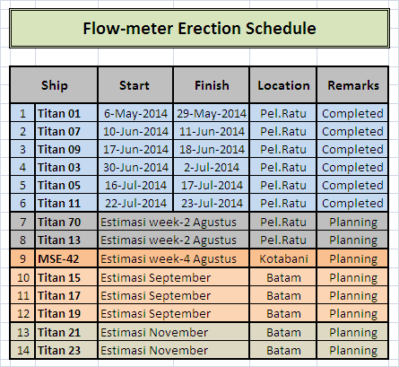
Figure1. Flow meter Erection Schedule

FUEL OIL CONSUMPTION
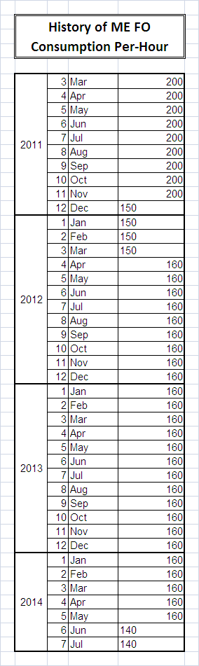

Table 1. Ship Main Engine Fuel Oil Consumption per-hour History

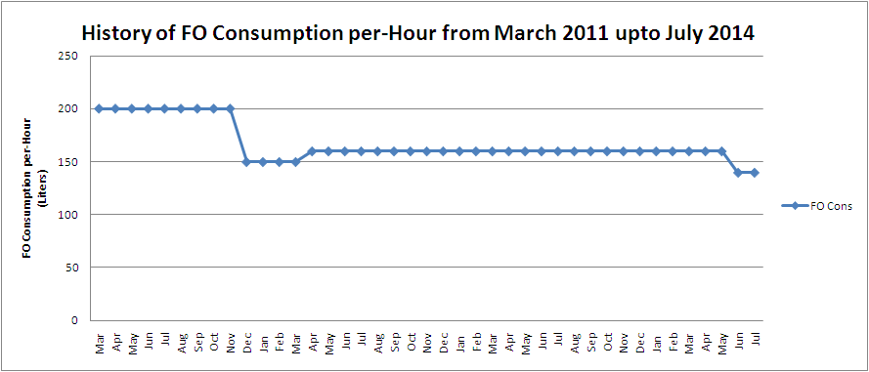

Figure 2 History of FO Consumption per hour from March 2011 till July 2014

Table 2. Ship FO Consumption on June 2014

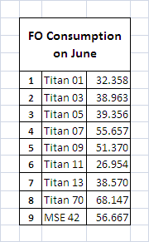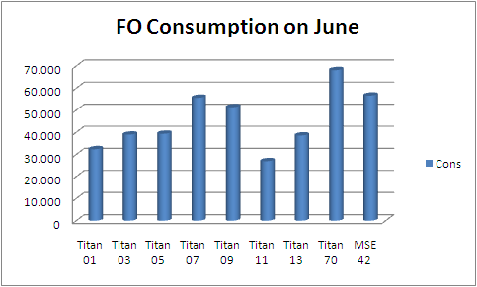

Figure 3. FO Consumption on June 2014

Table 3. Ship FO Consumption on July 2014

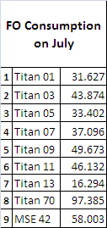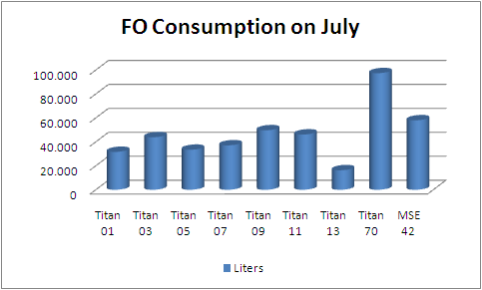

Figure 4. FO Consumption on July 2014

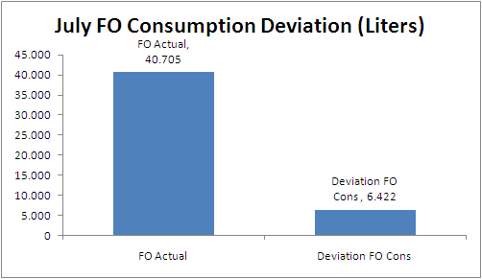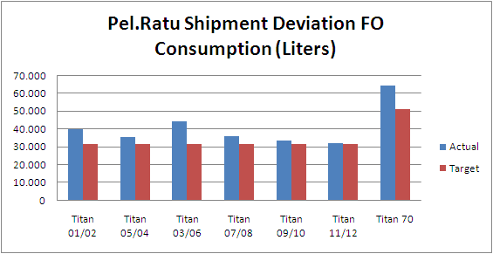

Figure 5. July FO Consumption Deviation Figure 6. Deviation FO Consumption
(liters) on July 2014 for all of the ship on July 2014

- Titan 01 FO Consumption Record on July:
FO consumption of Titan 01 stable not exceed 140 liter per-hour because have been installed flow meter censorship.

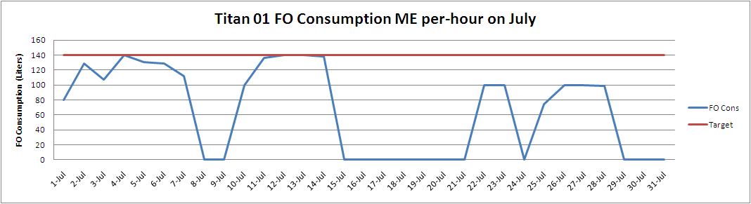

Figure 7. Titan 01 FO Consumption ME per hour on July

- Titan 03 FO Consumption Record on July:
FO consumption of Titan 03 steady but ever several times exceeding a little bit over 140 liter per-hour because of bad weather.

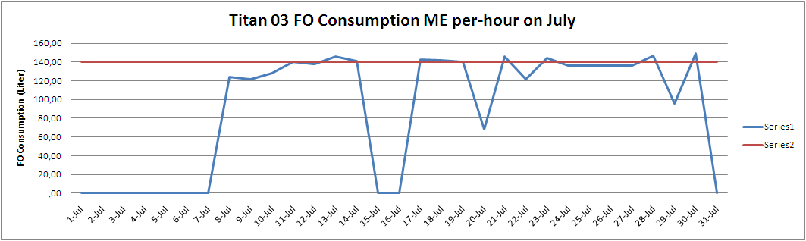

Figure 8. Titan 03 FO Consumption ME per hour on July
- Titan 05 FO Consumption Record on July:
FO consumption of Titan 05 stable not exceed 140 liter per-hour because has been installed censorship flow meter.
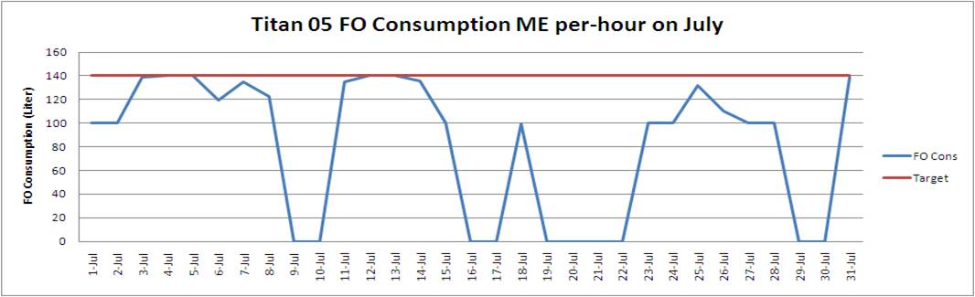
Figure 9. Titan 05 FO Consumption ME per hour on July

- Titan 07 FO Consumption Record on July:
FO consumption of Titan 07 steady but once exceeding a little bit over 140 liter per-hour because of bad weather.

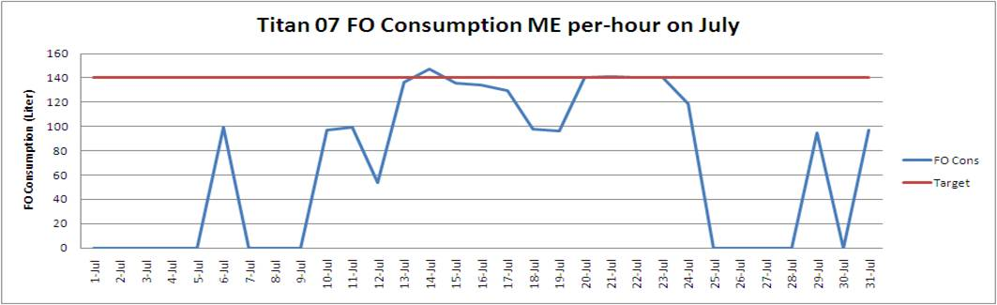

Figure 10. Titan 07 FO Consumption ME per hour on July

- Titan 09 FO Consumption Record on July:
FO consumption of Titan 09 stable not exceed 140 liter per-hour because has been installed censorship flow meter.
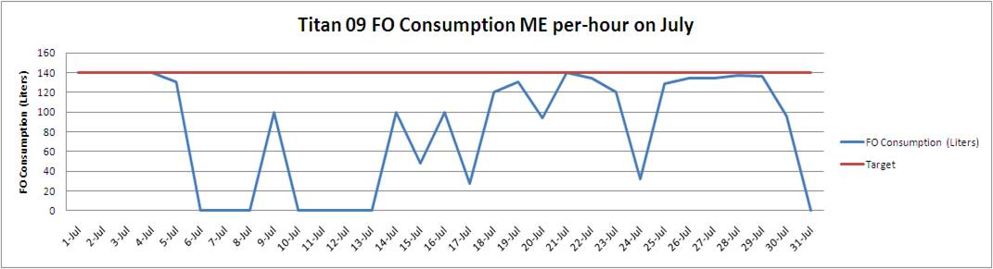
Figure 11. Titan 09 FO Consumption ME per hour on July
- Titan 11 FO Consumption Record on July:
FO consumption of Titan 11 stable not exceed 140 liter per-hour because have been installed flow meter censorship
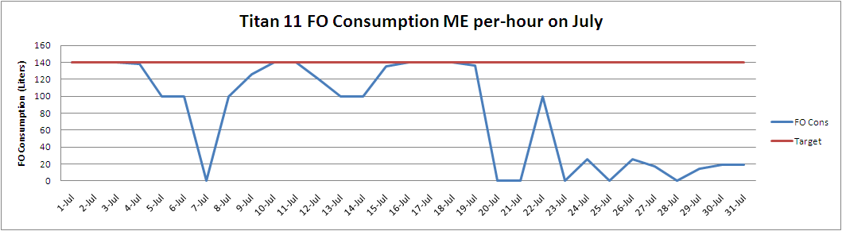
Figure 12. Titan 11 FO Consumption ME per hour on July
CONCLUSION
- Until July 2014, the number of vessels which has been installed flow meter is 6 of a vessel from a plan 14 ship ( 6 / 14 = 43 % ) and still 8 ships that has not been attached flow meter ( 8 / 14 = 57 % planning ).
- The target of fuel efficiency currently has reached roughly 92 % and is expected to the remaining 8 % can be resolved after all ships finished mounted of flow meter. For a while before a vessel fitted flow meter, the survey sounding FO-tank done by independent-surveyor.
References
- Aquametro-Contoil-Flowmeter.pdf
- Flow Measurement Handbook Industrial Designs, Operating Principles- Roger C. Baker - Google Books.
- http://www.caltex.com.au/sites/Marine/Products/Pages/MarineGasOil.aspx
- Source from log book and reading of flow meter data from TB Titan 01, 03, 05, 07, 09 and 11.

