A Study of Feminism on Keeva Tee’s Hierarchy of Needs in The Novel by Sadie Turner and Colette Freedman: Anomalies “The Rise of Underground”

TERM PAPER

By

Achmad Gustri Nugraha
2012130020

STRATA ONE (S-1) OF ENGLISH DEPARTMENT
FACULTY OF LETTERS
UNIVERSITY OF DARMA PERSADA
JAKARTA
2018
A Study of Feminism on Keeva Tee’s Hierarchy of Needs in the Novel by Sadie Turner and Colette Freedman: Anomalies “The Rise of Underground”

TERM PAPER
Submitted in part-fulfilling for obtaining
Strata One (S-1) Degree

By

Achmad Gustri Nugraha
2012130020

STRATA ONE (S-1) OF ENGLISH DEPARTMENT
FACULTY OF LETTERS
UNIVERSITY OF DARMA PERSADA
JAKARTA
2018
INTELLECTUAL PROPERTY STATEMENT PAGE

I hereby declare that the term-paper is the result of my own work, not a half or total plagiarism of someone else’s, and all of the sources quoted or referred to have been stated correctly based on the actual date and time.

Name : Achmad Gustri Nugraha

Reg. No : 2012130020

Signature :

Date : August 8th 2018

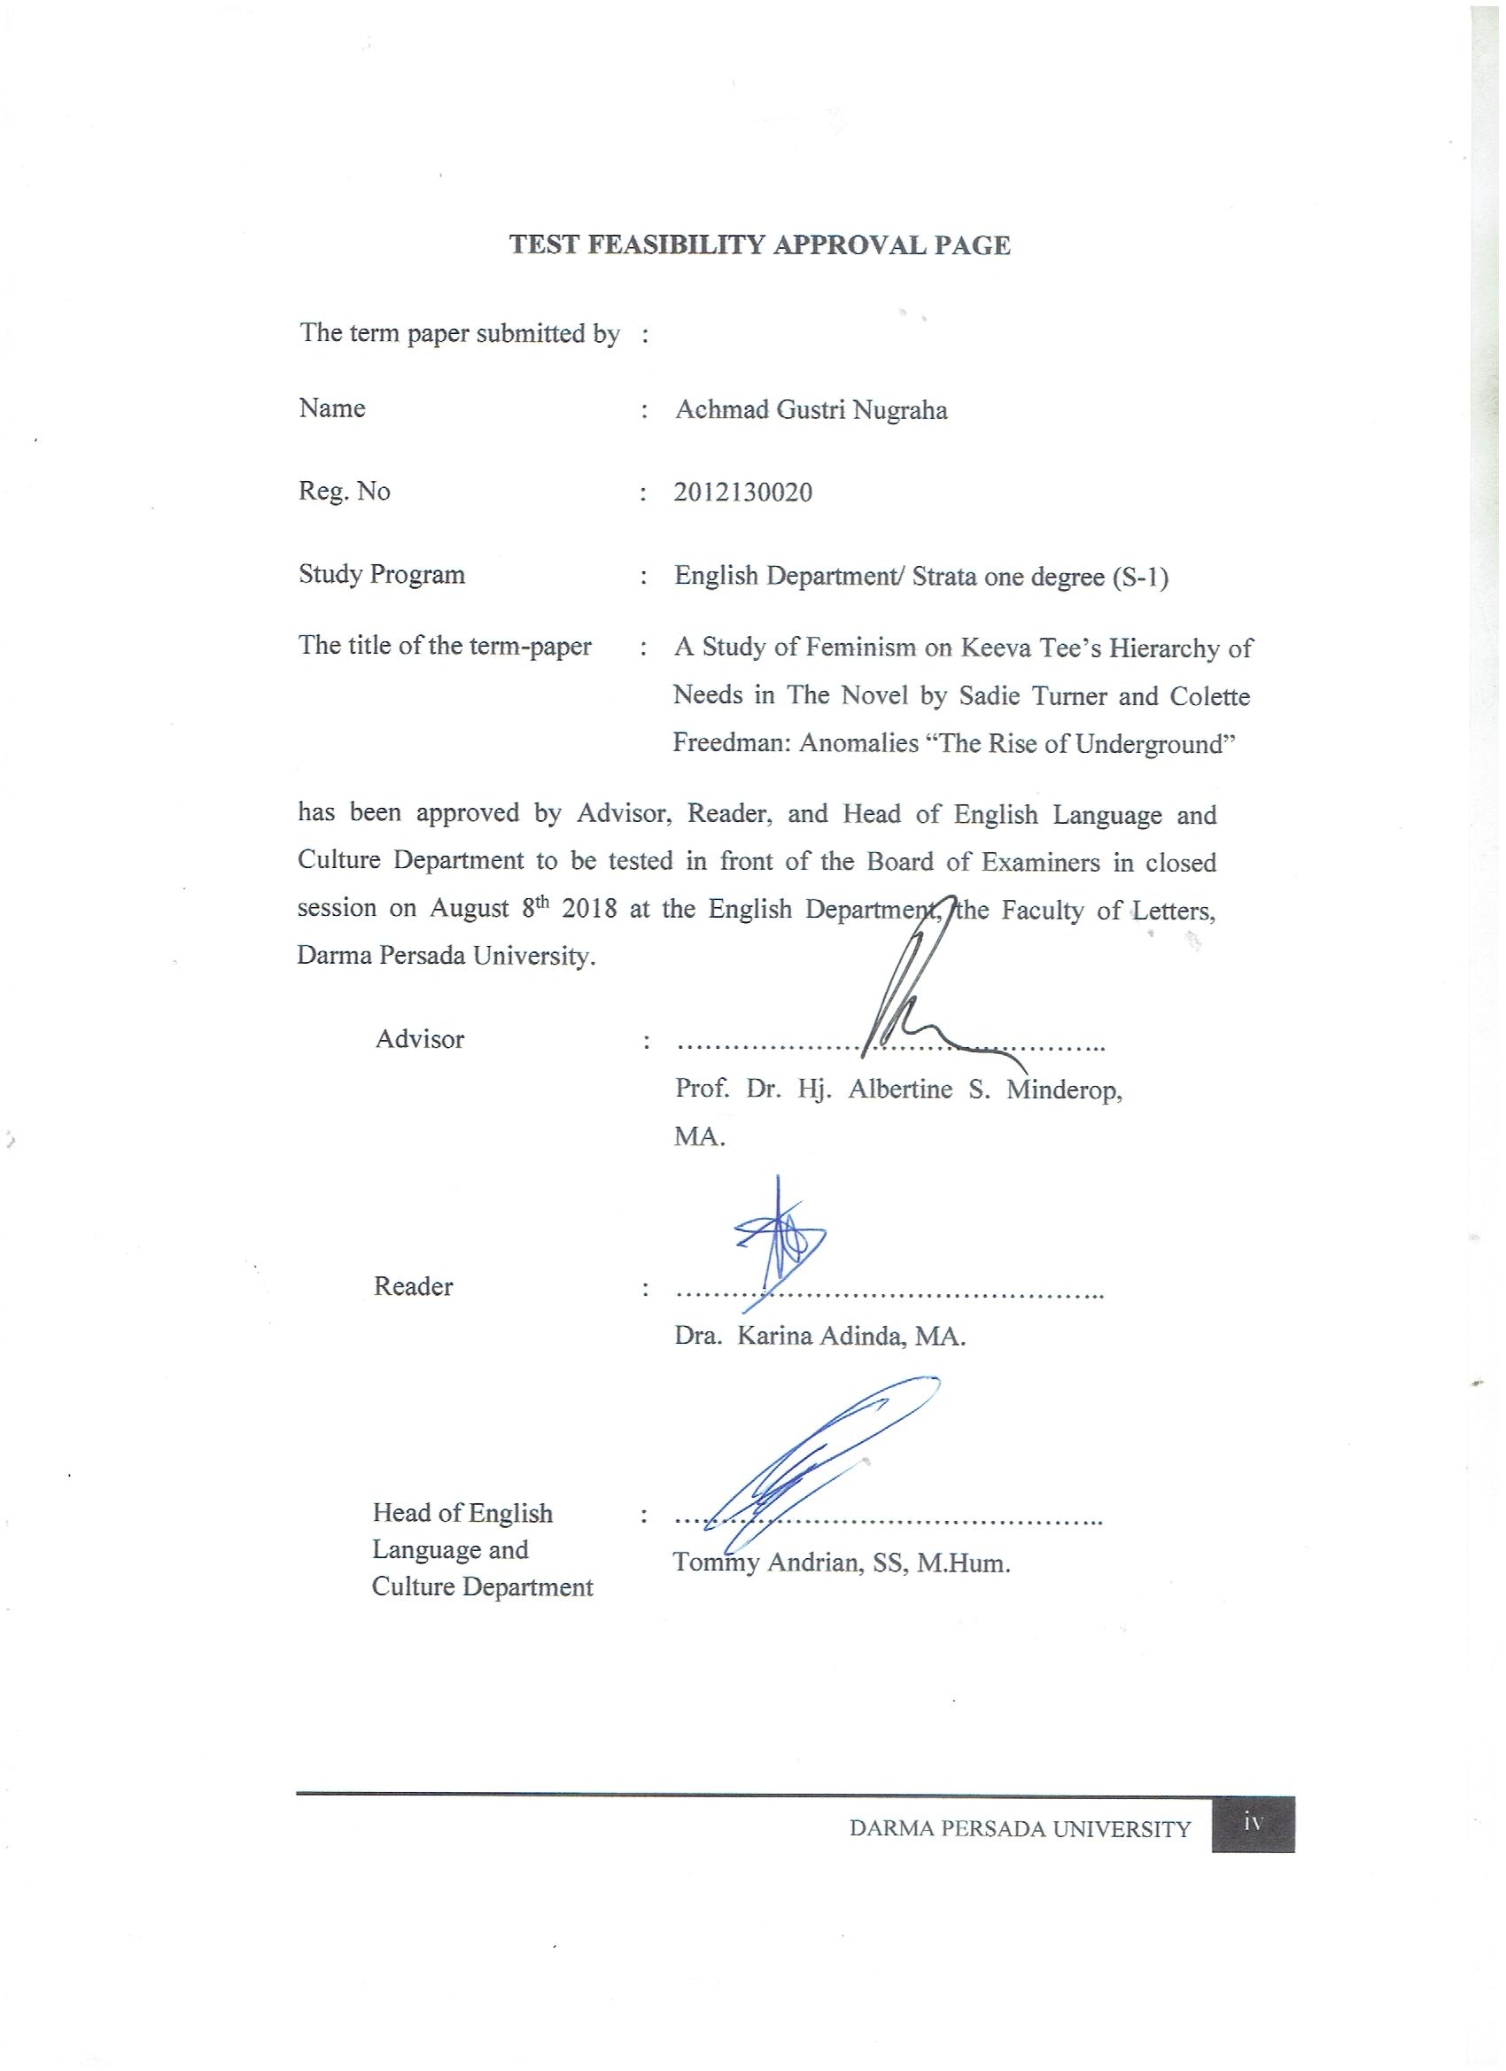

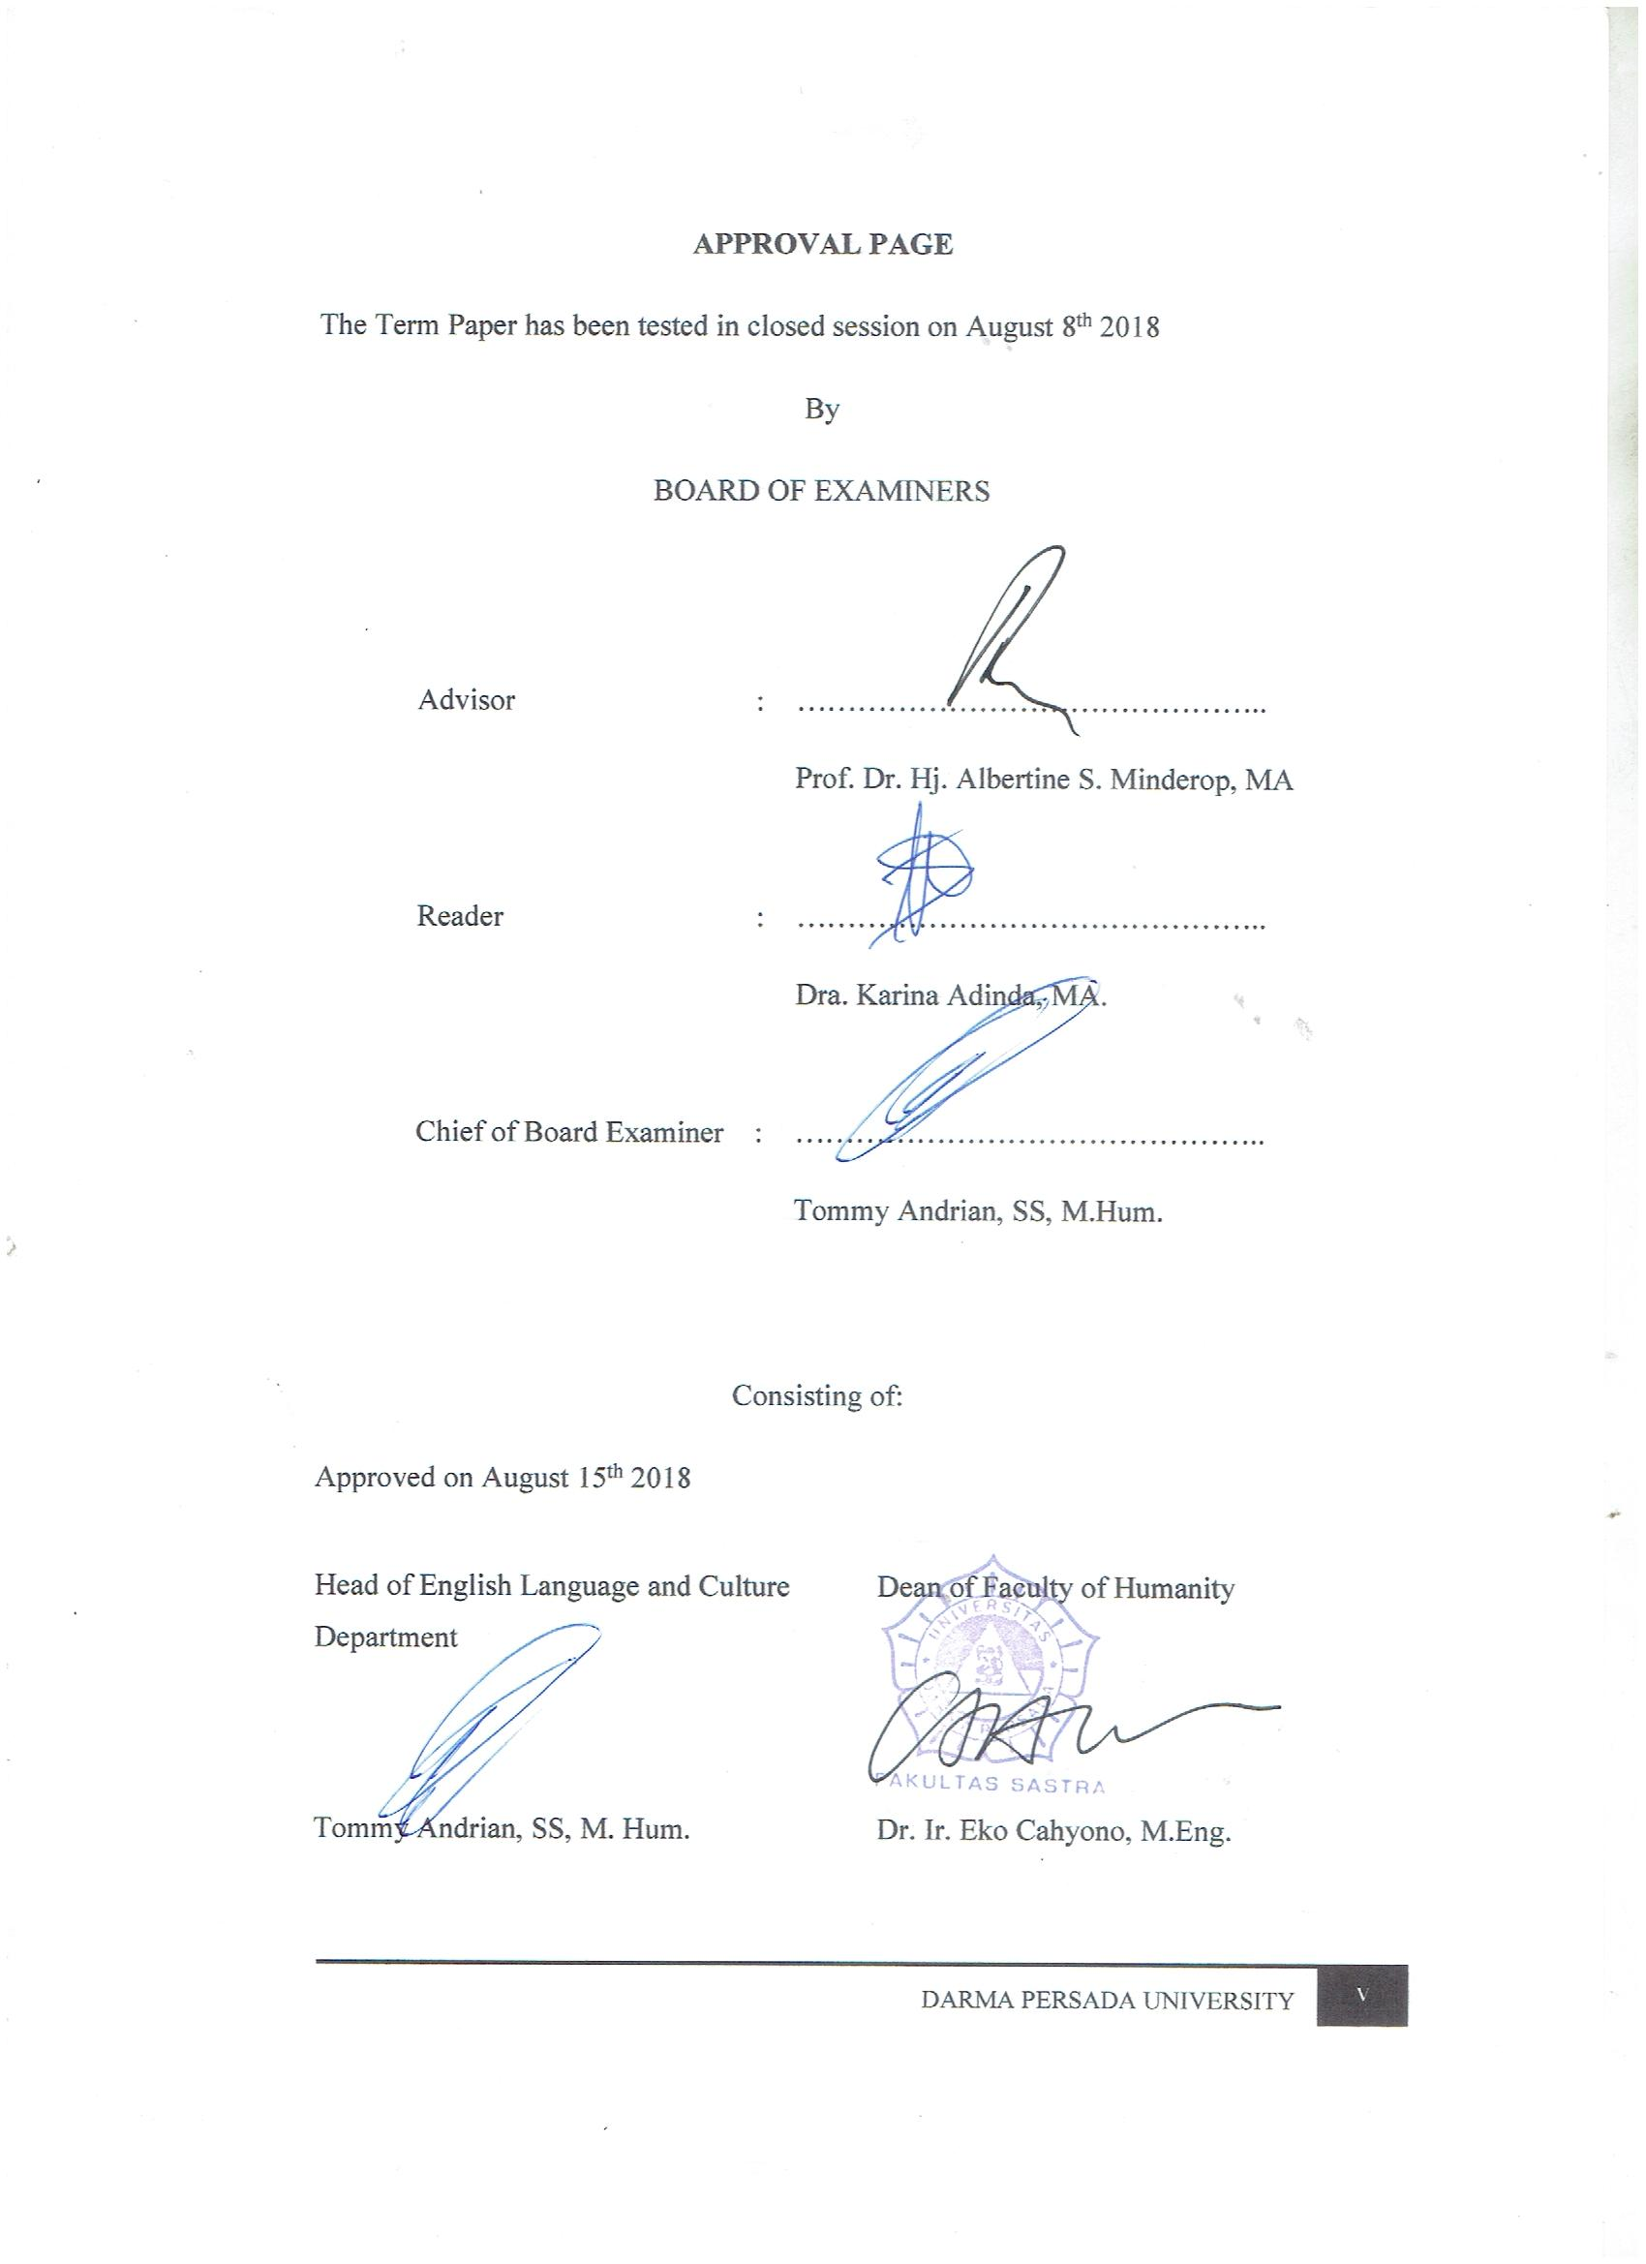

ACKNOWLEDGEMENT
Praise be Allah SWT, God who has given the mercy and blesses me to finish my research paper entitled A Study of Feminism on Keeva Tee’s Hierarchy of Needs in The Novel by Sadie Turner and Colette Freedman: Anomalies “The Rise of Underground”. This paper is submitted as a partial fulfillment of the requirements for obtaining the Strata One (S-1) degree at the English Department, The Faculty of Letters, and Darma Persada University.
Behind the writing process of this research paper, there are many great people who always guide, accompany and support me from the beginning until I finish this term-paper. Their endless advices are very meaningful for me to finish this term paper until the end. I would like to say a lot of gratitude to people who support me, those great people are:
- Mrs. Prof. Dr. Hj. Albertine S. Minderop, MA as the advisor who has guided has and helped me in the preparation of my term-paper.
- Drs. Karina Adinda, MSi as the reader who thoroughly has checked and corrected the word by word in this term-paper.
- Mr. Tommy Andrian, SS, M.Hum as the Head of English Department.
- Mrs. Prof. Dr. Hj. Albertine S. Minderop, MA as the academic supervisor, thanks for all advices and guidance during the lectures.
- Dr. Ir. Eko Cahyono, M.Eng as the Dean of Faculty of Letters.
- All lecturers in English Department who have given me so much knowledge and experiences.
- My beloved family who have given material assistance and moral support. Thank you very much to my lovely mother Yusni; My father, Chotib Erwin; My sisters, Sari Kemala Dwi and Mardiana. Thank you all as always praying the best wishes for me. You are the entire precious person who Allah SWT gives to me.
- My friends in English Department, class of 2012 until 2018, which always support and give many advices for me in every semester. You are the best for me.
- Diah Purnama Sari my best partner, Hafiz Arkan, Abror, Desman, Jhon, Ajie, Dennis, Della, Devi and others that I cannot mentioned one by one, but it does not lessen my respect to all of you who always ask and accompanying me to finish my term-paper, support me and give me advices and best wishes to my study.
- My friends in NUPOPO FAMILY, SENGON, all of you are the best groups and also in my life. Thanks for all your support and advices in good times and bad times. You guys are the best for me and thank you for the laugh and happy memories.
Overall, I hope that Allah SWT is pleased to give all the good of all for those who have helped. This term-paper is far from perfection, suggestions and constructive criticism are welcome to improve this term-paper. I hope this term-paper brings benefits to the next study for next generation of student that study literature of English.

Jakarta, 17 July 2018
Writer,

Achmad Gustri Nugraha
ABSTRACT
Name : Achmad Gustri Nugraha
Study Program : English Department S-1
Title : A Study of Feminism on Keeva Tee’s Hierarchy of Needs in The Novel by Sadie Turner and Colette Freedman: Anomalies “The Rise of Underground”
This term paper discusses about a literary work, a novel. The problems are the characterization and relate it to Maslow’s hierarchy of needs. It is analyzed by using intrinsic and extrinsic approaches. Through the intrinsic approach, the concepts I apply are: characterization – showing method; through dialogue and through action; setting, and plot, and for the extrinsic approach, the concept is: Hierarchy of needs by Abraham Maslow and concept feminism. This term paper is variety of qualitative research, types of library research, interpretative analysis using the method by collecting data in the form of literary work from the novel Anomalies The Rise of Underground by Sadie Turner and Colette Fredman as the primary source and is supported by some of the literatures that relate to the theories, concepts and the relevant definition as the secondary sources.
Keywords: Characterization, Kevaa Tee character, Maslow’s Hierarchy of Needs, Feminism
ABSTRAK
Nama : Achmad Gustri Nugraha
Program Studi : S-1 Sastra Inggris
Judul Penelitian : A Study of Feminism on Keeva Tee’s Hierarchy of Needs in The Novel by Sadie Turner and Colette Freedman: Anomalies “The Rise of Underground”
Skripsi ini membahas tema karya sastra berupa novel. Masalah yang akan dianalisis adalah perwatakan dan menghubungkannya dengan teori kebutuhan bertingkat pada teori Abraham Maslow dan konsep Feminisme dengan menggunakan pendekatan intrinsik dan ekstrinsik. Melalui pendekatan intrinsik diterapkan konsep-konsep : perwatakan, metode tidak langsung melalui dialog dan melalui tindakan; latar, dan alur; dan untuk pendekatan ekstrinsik digunakan konsep: teori kebutuhan bertingkat oleh Abraham Maslow dan kosep Feminist. Penelitian ini adalah penelitian ragam kualitatif, jenis penelitian kepustakaan, sifatnya interpretative/ analisis dengan metode penggumpulan data karya sastra dari film yang berjudul The Rise of Underground by Sadie Turner dan Colette Fredman. Sebagai sumber primer dan didukung oleh beberapa literature yang terkait dengan teori, konsep dan definisi yang relevan sebagai sumber sekunder.
Kata kunci: Perwatakan, Watak Keeva Tee, Teori Kebutuhan Bertingkat dari Abraham Maslow, Feminisme
TABLE OF CONTENTS

PAGE OF THE TITLE i INTELLECTUAL PROPERTY STATEMENT PAGE ii
TEST FEASIBILITY APPROVAL PAGE iii
APPROVAL PAGE iv
ACKNOWLEDGEMENT v
ABSTRACT vii
ABSTRAK viii
TABLE OF CONTENTS ix

CHAPTER I: INTRODUCTION 1
1.1. Background of the Research 1
1.2. Identification of the Problem 6
1.3. Limitation of the Problem 6
1.4. Formulation of the Problem 6
1.5. Objective of the Research 6
1.6. Methods of the Research 7
1.7. Benefits of the Research 7
1.8. Systematic Organization of the Research 7

CHAPTER II: FRAMEWORK OF THEORIES 9
2.1. Intrinsic Approaches 9
2.1. Characterizations 9
2.1.1. Showing Method 10
2.1.1.1. Showing Method 10
2.1.1.1.1. Characterization through Dialogue 10
2.1.1.1.2. Characterization through Action 10
2.1.2. Setting 10
2.1.2.1. Setting as background of action 11
2.1.2.2. Setting as antagonist 11
2.1.2.3. Setting as means of creating appropriate atmosphere 11
2.1.2.4. Setting as means revealing character 11
2.1.2.5. Setting as reinforcing of theme 12
2.1.3. Plot 12
2.1.3.1. Exposition 12
2.1.3.2. Complication 12
2.1.3.3. Crisis 13
2.1.3.4. Falling Action 13
2.1.3.5. Resolution 13
2.2. Extrinsic Approach 13
2.2.1. Maslow’s Hierarchy of Needs 13
2.2.1.1. Physiological Needs 14
2.2.1.2. Safety Needs 14
2.2.1.3. Social Needs 15
2.2.1.4. The Esteem Needs 15
2.2.1.5. Self-actualization 15
2.2.2. Concept of Feminism 17

CHAPTER III: THE ANALYSIS OF ANOMALIES KEEVA TEE CHARACTERS THROUGH INTRINSIC APPROACH………………………..……………………. 21
3.1. Characterizations 21
3.1.1. Keeva Tee 22
3.1.1.1. Nervous 22
3.1.1.2. Friendly 26
3.1.2. Claudia Durant 28
3.1.3. Sobek Vasely 28
3.2. Setting 29
3.2.1. Setting as Background of Action 29
3.2.1.1. At the Monarch Camp, Central America 29
3.2.1.2. At the Keeva House 30
3.2.1.3. At the Sabat City 30
3.2.2. Setting as Antagonist 31
3.2.2.1. At the Monarch Camp 31
3.2.3. Setting as a Means of Creating Appropriate Atmosphere 31
3.2.3.1. At the Monarch Camp 32
3.2.3.2. At the Monarch Camp 32
3.2.4. Setting as a Means of Revealing Character 33
3.2.4.1. At the Monarch Camp 33
3.2.5. Setting as a Means of Reinforcing Theme 33
3.2.5.1. At the Monarch Camp 33
3.2.5.2. At the Monarch Camp 34
3.3. Plot 34
3.3.1. Exposition 35
3.3.2. Rising Action 36
3.3.3. Climax 36
3.3.4. Falling Action 37
3.3.5. Resolution 38
3.4. Summary of the Chapter 39

CHAPTER IV: A Study of Feminism on Keeva Tee’s Hierarchy of Needs in the Novel by Sadie Turnerr and Colette Freedman: Anomalies “The Rise of Underground” 40
4.1. A Study of Feminism on Keeva Tee 40
4.1.1. Radical Feminism on Character Keeva Tee 41
4.1.2. Radical Feminism on Plot exposition, rising action, climax, falling action and resolution 41
4.2. The Hierarchy of Needs of Keeva Tee 42
4.2.1. Physiological Needs 43
4.2.1.1. Keeva Tee’s Protector Character at the War Zone which
Need Rest 43
4.2.1.2. Keeva Tee’s Leader Character in the Forest which Need
Food 44
4.2.2. Security Needs 45
4.2.2.1. Keeva Tee;s Caring Character in the Monarch Camp which
Need Preserve 45
4.2.2.2. Keeva Tee’s Selfish Character as Setting as Antagonist
which Need Safety 45
4.2.3. Social Needs 46
4.2.3.1. Keeva Tee’s Caring Character in the Forest which Need
Love 46
4.2.3.2. Keeva Tee’s Protector Character in the Forest which
Need Friendship 47
4.2.4. Esteem Needs 48
4.2.4.1. Keeva Tee’s Caring Character in the Forest which
Need Prestige 48
4.2.4.2. Keeva Tee’s Selfish as Setting as Antagonist which
Need Feeling of Accomplishment 48
4.2.5. Self-actualizing Needs 49
4.2.5.1. Keeva Tee’s Caring Character as the Resolution which
Need Achieving One’s Full Potential 49
4.1.5.2. Keeva Tee’s Caring Character as the Resolution which
Need Including Creative Activities 50
CHAPTER V: CONCLUSION 52
REFERENCES 54
ABOUT THE AUTHOR 56
SCHEME OF THE RESEARCH 57
POSTER OF THE RESEARCH 58
CURRICULUM VITAE

