FACE THREATENING ACTS IN THE FIRST PRESIDENTIAL DEBATE BETWEEN DONALD TRUMP AND HILLARY CLINTON ON 26TH SEPTEMBER 2016: A STUDY OF PRAGMATICS

TERM PAPER

EVA SEPTIANI
2014130030

STRATA ONE (S-1) OF ENGLISH LANGUAGE AND CULTURE DEPARTMENT FACULTY OF HUMANITIES
UNIVERSITY OF DARMA PERSADA
JAKARTA
2018
FACE THREATENING ACTS IN THE FIRST PRESIDENTIAL DEBATE BETWEEN DONALD TRUMP AND HILLARY CLINTON ON 26TH SEPTEMBER 2016: A STUDY OF PRAGMATICS

TERM PAPER
Submitted in partial-fulfilling for obtaining
Strata One (S-1) Degree

EVA SEPTIANI
2014130030

STRATA ONE (S-1) OF ENGLISH LANGUAGE AND CULTURE DEPARTMENT FACULTY OF HUMANITIES
UNIVERSITY OF DARMA PERSADA
JAKARTA
2018
INTELLECTUAL PROPERTY STATEMENT PAGE

I hereby declare that the term paper entitled ‘Face Threatening Acts in the First Presidential Debate between Donald Trump and Hillary Clinton on 26th September 2016: A study of Pragmatics’ is the result of my own work and not half or total plagiarism of someone else’s, the contents have become my responsibility. All the sources quoted or referred to have been stated correctly based on the actual date and time.

Name : Eva Septiani

Registration Number : 2014130030

Signature :

Date : August 10th, 2018

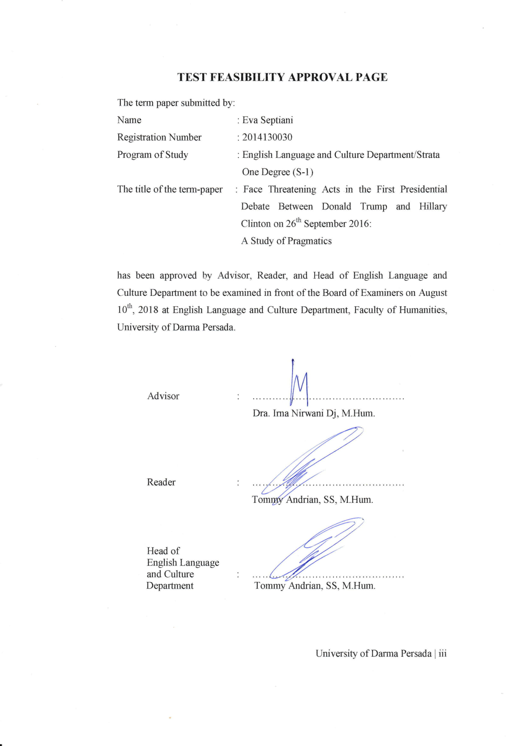

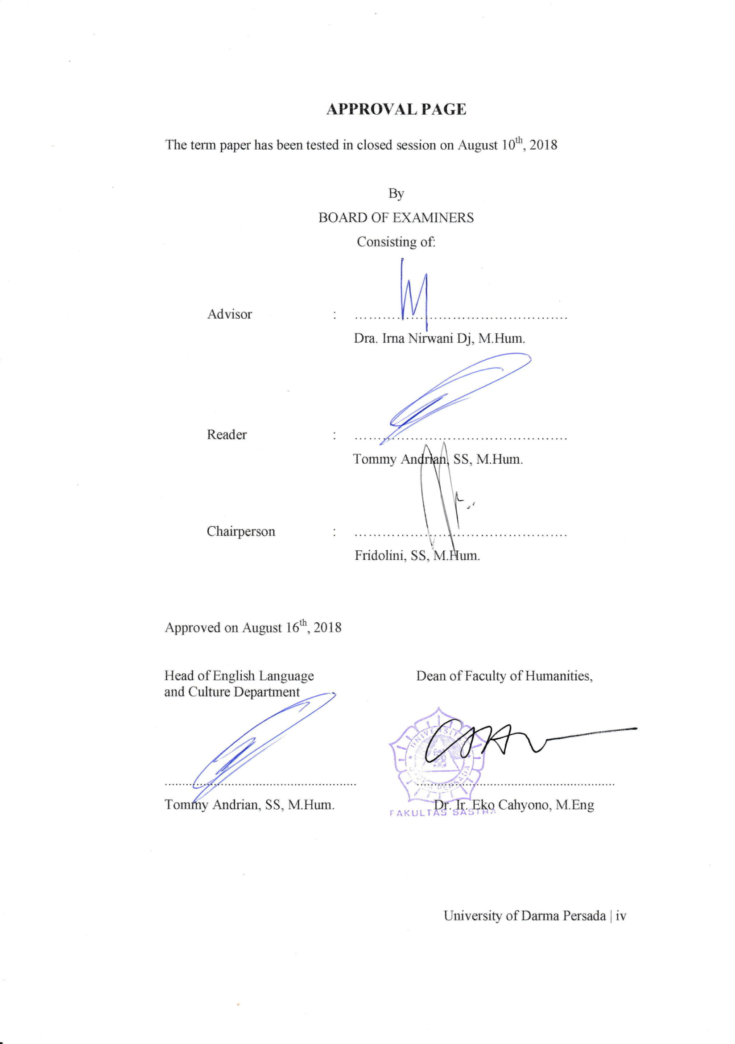

ACKNOWLEDGEMENT
First of all, I want to express my highest gratitude to Allah SWT for his blessing love, opportunity, health, mercy, strength, and power to complete this term paper entitled ‘Face Threatening Acts in the First Presidential Debate between Donald Trump and Hillary Clinton on 26th September 2016: A Study of Pragmatics’, Submitted in part fulfilling for obtaining Strata one (S-1) degree in English Language and Culture Department Faculty of Humanities, University of Darma Persada.
I am very happy to be a part of English Language and Culture Department Faculty of Humanities, University of Darma Persada for 4 years. I get so many valuable lessons from lecturers who always inspire me and teach me many good things about the subject or about life. I also get a lot of valuable experience such as following various organizations, so I can learn to use my time wisely between organizations and education. I would like to say my deepest gratitude to people who deserve this as they get involved in this term paper and support me to reach my goal:
- Tommy Andrian, SS,M.Hum, as the Head of English Language and Culture Department, the one who taught me many an interesting and a new thing that very useful and make me want to learn more;
- Dra. Irna Nirwani Dj,M.Hum, as the First Advisor in writing term paper, who kindly gives her time to guide me and gives some advices in a mother’s ways. She always helps me to grow in her own way;
- Tommy Andrian, SS,M,Hum as the reader of this term paper, who very patiently checking my term paper. He is one of my favorite lecturer, whose subject, legal translation, is one of my favorite;
- All of the lecturer in English Language and Culture Department, who have given me so much knowledge and experiences that help me to write this term paper;
- My lovely family, who always supports me morally, financially, and emotionally in doing this term paper without putting pressure on me. They are my strength to complete this term paper. Their support cannot be forgotten;

- My beloved friends, Widya, Yuli, Uha and Ella, who always colors my day, asks the process of this term paper, gives me a lots of advice, always beside me under any circumstance, always gives me suggestion and willingness to help me since the beginning of writing this term paper;
- All of my friends, who also are writing term paper for supporting and helping each other, whose name I cannot mention one by one.
I know there are still imperfections. Therefore, I warmly welcome suggestions and constructive critics.

Jakarta, August 10th,2018
Writer

Eva Septiani jnn

ABSTRACT

Name : Eva Septiani
Program of Study : English Language and Culture Department
The Title : Face Threatening Acts in the First Presidential Debate
between Donald Trump and Hillary Clinton on 26th September 2016: A Study of Pragmatics

Pragmatics is a branch of linguistics that studies the relationship between content and meaning. In the communication, we have to save people face and our face, because every participant in the social process has the need to be appreciated by others and the need to be free and not interfered with. This term paper discusses about politeness strategy and face threatening acts that are performed in the debate candidate’s utterances in the first presidential debate between Donald Trump and Hillary Clinton on 26th September 2016. This term paper also aims to find out what politeness strategy and FTAs that are the most frequently used and describe the purposes behind it. The fact that there are different contexts in every utterances, the writer assumes that those utterances have different politeness strategies and FTAs. For this reason, the theory of politeness strategies such as Bald-On-Record, Positive Politeness, Negative Politeness, Off-Record and FTAs such as Positive and Negative Face is conducted through qualitative approach. The research result shows that there are 139 total occurrences of politeness strategies and 139 total occurrences of FTAs either positive or negative face that used by Donald Trump and Hillary Clinton. FTAs that the most frequently used by Trump and Clinton is Negative Face with 72 total occurrences by Trump and 48 total occurrences by Clinton.

Keywords: negative face, positive face, negative politeness
ABSTRAK

Nama : Eva Septiani
Program studi : Bahasa dan Kebudayaan Inggris
Judul : Face Threatening Acts in the First Presidential Debate
between Donald Trump and Hillary Clinton on 26th September 2016: A Study of Pragmatics

Pragmatik adalah cabang ilmu linguistik yang mempelajari hubungan antara konteks dan makna. Setiap peserta didalam proses social memiliki kebutuhan untuk dihargai oleh orang lain dan kebutuhan untuk bebas dan tidak terganggu. Skripsi ini mendiskusikan tentang strategi kesopanan dan tindakan mengancam muka yang ditemukan pada tuturan peserta debat dalam ‘First Presidential Debate between Donald Trump and Hillary Clinton on 26th September 2016’. Skripsi ini bertujuan untuk menemukan strategi kesopanan dan tindakan mengancam muka yang paling sering digunakan dan mengemukakan tujuan atas penggunaan strategi dan tindakan tersebut. Adanya perbedaan konteks pada setiap ujaran yang disampaikan, penulis berasumsi bahwa ujaran tersebut menggunakan strategi dan tindakan mengancam muka yang berbeda. Oleh karena itu, teori mengenai strategi kesopanan seperti strategi langsung tanpa basa-basi, kesopanan positif, kesopanan negative, dan strategi tidak langsung serta tindakan mengancam muka seperti muka positif dan muka negative digunakan dalam penelitian ini. Penelitian ini menggunakan metode kualitatif. Hasil penelitian menunjukan bahwa total keempat strategi yang digunakan Donald Trump dan Hillary Clinton terjadi sebanyak 139 kali dan tindakan mengancam muka baik muka negatif atau positif yang digunakan oleh Donald Trump dan Hillary Clinton terjadi sebanyak 139 kali. Tindakan mengancam muka yang sering digunakan oleh Trump dan Clinton adalah wajah negatif dengan total 72 kali dan 48 kali.

Kata Kunci: wajah negatif, wajah positif, kesopanan negatif

TABLE OF CONTENTS

PAGE OF TITLE
INTELLECTUAL PROPERTY STATEMENT PAGE ii
TEST FEASIBILITY APPROVAL PAGE iii
APPROVAL PAGE iv
ACKNOWLEDGEMENT v
ABSTRACT vii
ABSTRAK viii
TABLE OF CONTENTS ix

CHAPTER 1: INTRODUCTION 1
1.1 Background of the Research 1
1.2 Identification of the Problems 4
1.3 Limitation of the Problems 4
1.4 Formulations of the Problems 4
1.5 Objectives of the Research 4
1.6 Framework of the Research 5
1.7 Method of the Research 5
1.8 Benefits of the Research 6
1.9 Systematic Organization of the Research 6

CHAPTER 2: FRAMEWORK OF THE THEORIES 8
2.1 Politeness Theory 8
2.2 Politeness Strategy 11
2.2.1 Bald-On-Record 11
2.2.2 Positive Politeness 12
2.2.3 Negative Politeness 12
2.2.4 Off-Record 12
2.3 Face Work 13
2.3.1 Positive Face 13
2.3.2 Negative Face 14
2.4 Face Wants 14
2.5 FTA (Face Threatening Acts) 14
2.5.1 FTAs Threatening the Hearer’s Face 15
2.5.1.1 Positive Face 15
2.5.1.2 Negative Face 15
2.5.2 FTAs Threatening the Speaker’s Face 16
2.5.2.1Positive Face 16
2.5.2.2 Negative Face 10
2.6 Social Factor 17
2.7 Power 17
2.8 Social Distance 17
2.9 Rate of Imposition 17

CHAPTER 3: FACE THREATENING ACTS IN THE FIRST
PRESIDENTIAL DEBATE BETWEEN
DONALD TRUMP AND HILLARY CLINTON
ON 26TH SEPTEMBER 2016:
A STUDY OF PRAGMATICS 18
CHAPTER 4: CONCLUSION 109
REFERENCES 112
SCHEME OF THE RESEARCH 114
POSTER OF THE RESEARCH 115
CURRICULUM VITAE ATTACHMENT 116

