INTERPRETATION OF SIGNS
IN NIKE THIS IS US ADVERTISEMENT:
A STUDY OF SEMIOTICS

TERM PAPER

SEPTIA RAHAYU
2014130062

STRATA ONE (S-1) OF ENGLISH LANGUAGE AND CULTURE DEPARTMENT
FACULTY OF HUMANITIES
UNIVERSITY OF DARMA PERSADA
JAKARTA
2018
INTERPRETATION OF SIGNS
IN NIKE THIS IS US ADVERTISEMENT:
A STUDY OF SEMIOTICS

TERM PAPER

Submitted in Partial Fulfillment of the Requirements
for Strata One (S1) Degree

SEPTIA RAHAYU
2014130062

STRATA ONE (S-1) OF ENGLISH LANGUAGE AND CULTURE DEPARTMENT
FACULTY OF HUMANITIES
UNIVERSITY OF DARMA PERSADA
JAKARTA
2018
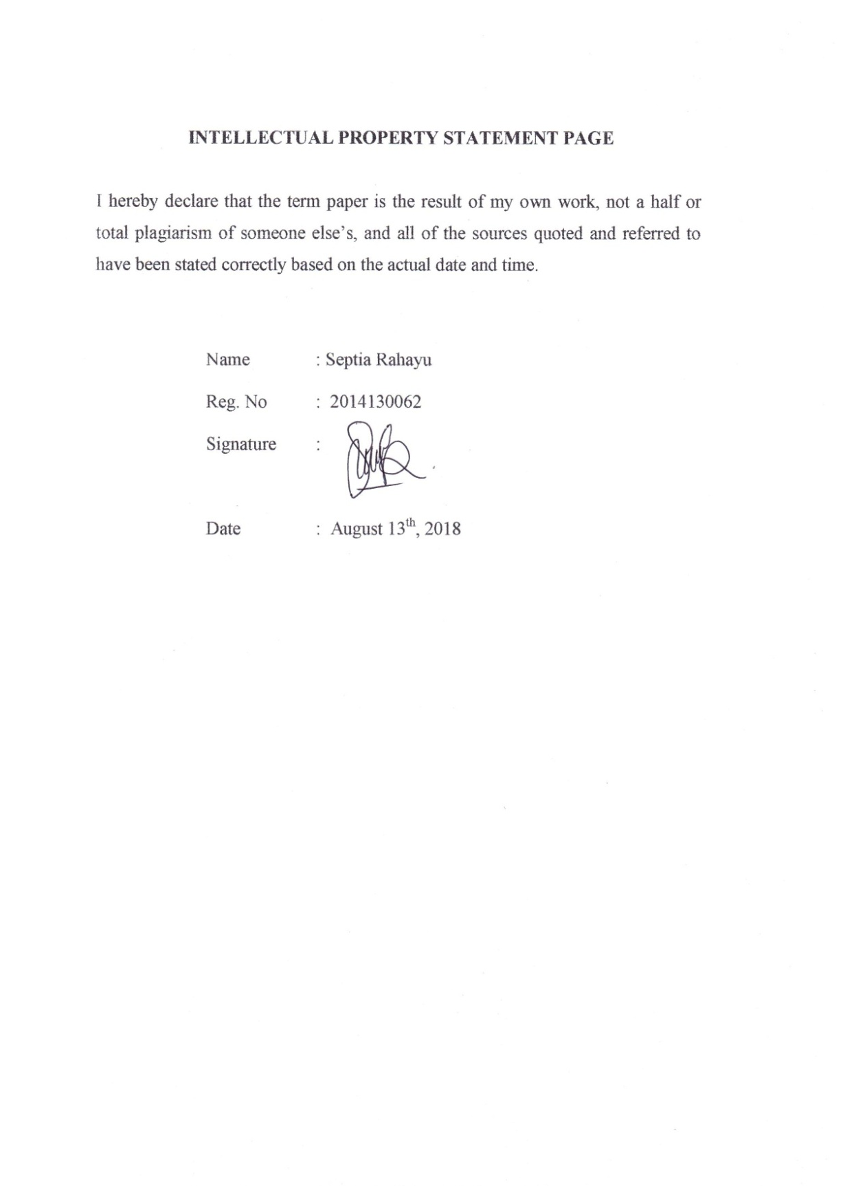

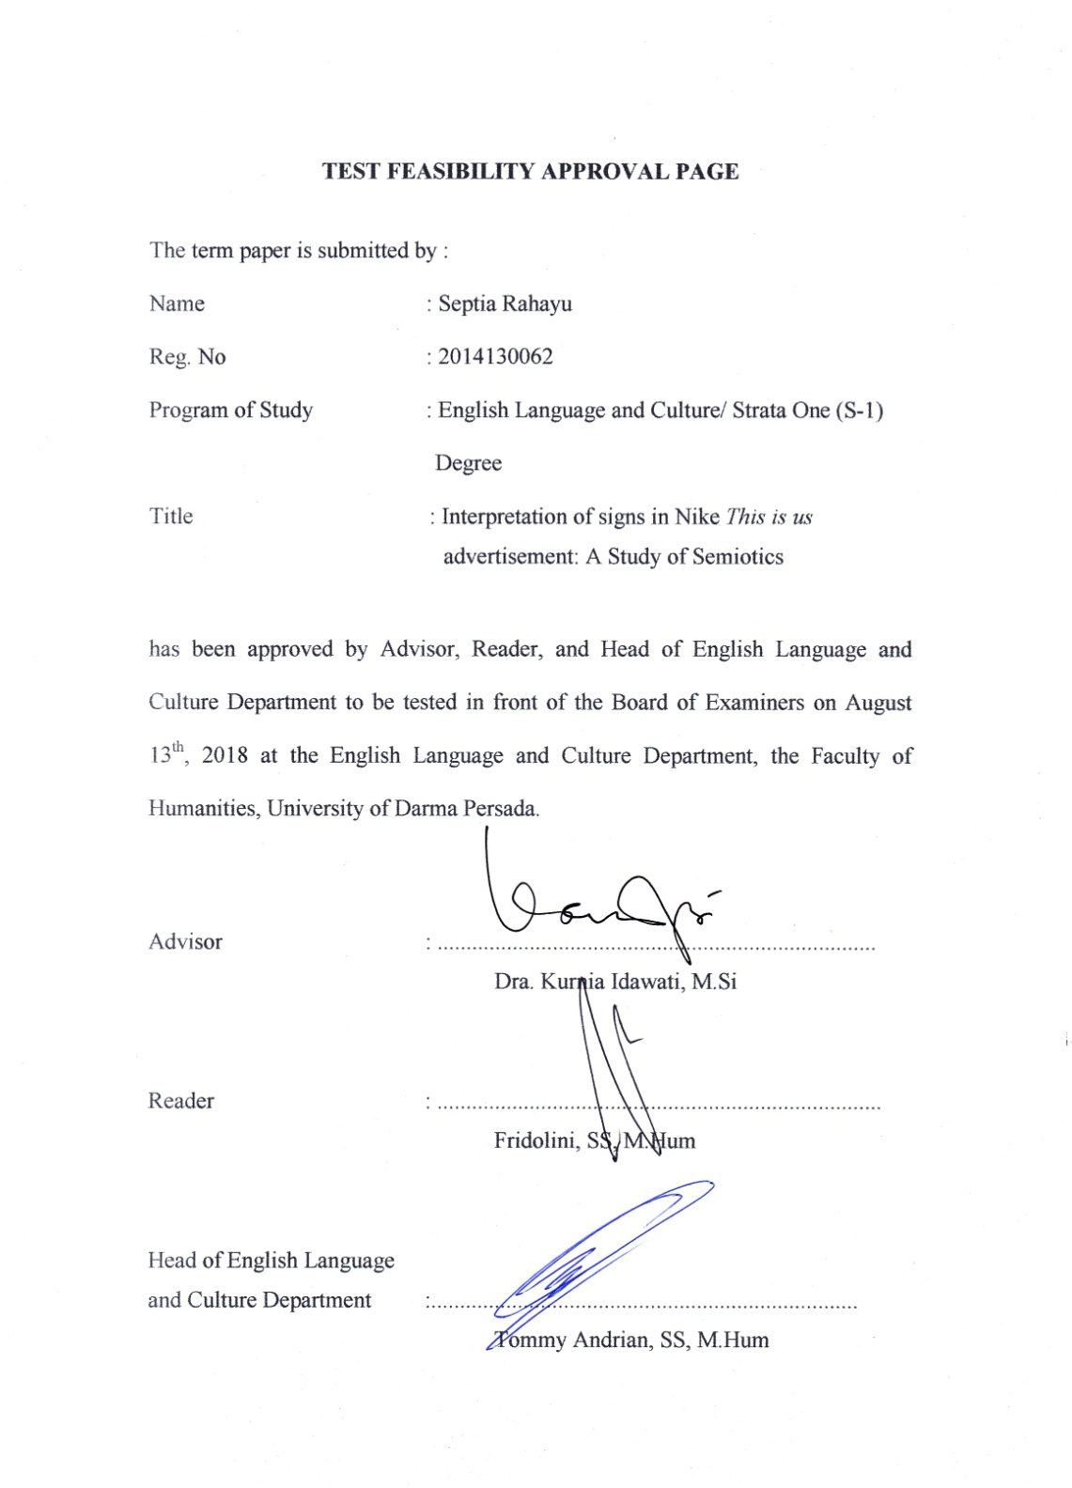

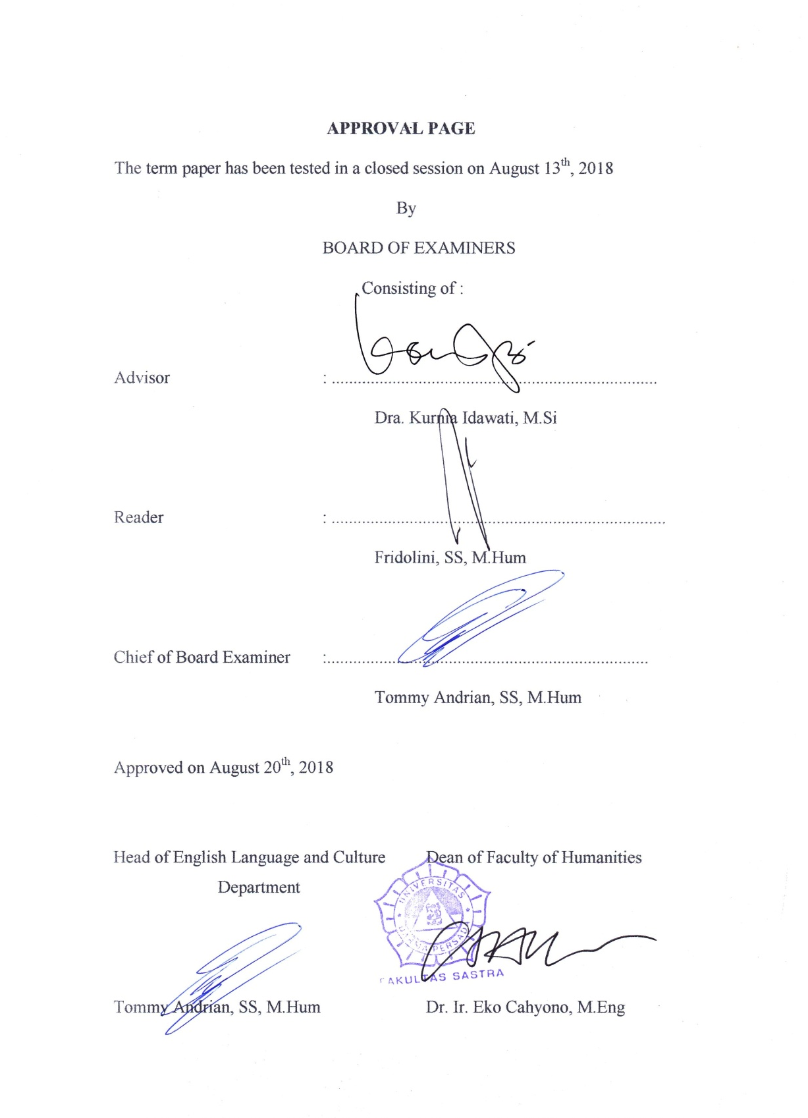

ACKNOWLEDGEMENT

There is no word better than praise be to Allah SWT, who always gives me his guidance, mercy, strength and blessings to finish this term paper entitled Interpretation of signs in Nike “This is us” advertisement: a study of semiotics. This term paper is submitted to the Strata One Program, English Language and Culture Department of Darma Persada University as a partial fulfillment of the requirements for obtaining the Strata One (S1) degree. I as the researcher, realize that the research is still far from being perfect. Therefore, if this research can probably be the references by the others, it is welcomed to be.
I would like to express my sincere gratitude to some outstanding people behind the making of this term paper as listed as follow :
- Dra. Kurnia Idawati, M.Si as the advisor in writing this term paper who has given a lot of her time to guide me and always gives me suggestions and motivating words to finish this term paper. Thank you very much, Ma’am.
- Fridolini, SS, M.Hum as the reader who has given her time to guide me and correct the things in this term paper. Thank you for not only being my reader but also my advisor.
- Tommy Andrian, SS, M. Hum as the Head of English Language and Culture and the Chair person of Examiner, who puts all of his concern by giving the advice and corrections.
- Eka Yuniar, SS, M.Si as the academic advisor who has already taught and guided me a lot of learning from the first semester until the last.
- Dr. Ir. Eko Cahyono, M.Eng as the Dean of Faculty of Humanities.
- All beloved lecturers in English Language and Culture Department such as Miss Nurul, Mr. Agus, Mr. Juliansyah, Mrs. Karina and the others who have given their time to motivate me to finish this term paper.
- My mom and dad, who give their loves and incredible supports to me, I am very thankful to have them as my parents.
- Okta Rahmawati who has inspired and motivated me throughout the hardest time in doing this term paper. Thank you

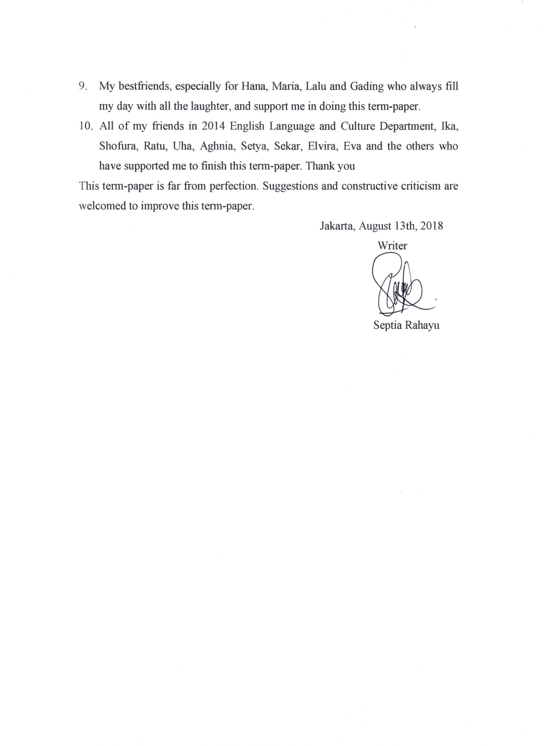

ABSTRACT

Name : Septia Rahayu
Study program : English Language and Culture Department
The title of the term paper : Interpretation of Signsin Nike This is us
advertisement: A Study of Semiotics

The research discusses about the interpretation of signs in Nike This is us advertisement. It will be analyzed using cultural approach and semiotics theory by Charles Sanders Peirce. The researcher will determine which are the signs in the advertisement and use them as the data. From the data, the researcher analyzes the object of the icon or the symbol, and finally gets the interpretant in order to give the meaning of the signs in the advertisement. The aims of the research are to find out the semiosis process and the message in Nike This is us advertisement. This research also aims to reveal the implication of the message. The analysis technique used here is descriptive method. The method is used to describe the processes of interpetation of the signs in the advertisement.

Keywords : Advertisement, Semiosis process, Nike This is us, Semiotics, Implication of the message.

ABSTRAK

Nama : Septia Rahayu
Program Studi :Bahasa dan Kebudayaan Inggris
Judul Skripsi :Interpretation of Signs in Nike This is us
advertisement : A Study of Semiotics

Penelitian ini membahas tentang interpretasi tanda di dalam iklan Nike This is us. Kajian ini akan dianalisis melalui pendekatan budaya dan teori semiotika dari Charles Sanders Peirce. Peneliti akan menentukan tanda-tanda yang ada di dalam iklan dan menggunakan tanda-tanda tersebut sebagai data. Peneliti menganalisa objek dari ikon atau simbol hingga akhirnya mendapat interpretasi untuk memberikan makna pada tanda yang ada di dalam iklan. Tujuan dari penelitian ini adalah untuk mengetahui proses semiosis dan pesan dari iklan Nike This is us. Penelitian ini juga bertujuan untuk mengungkap implikasi dari pesan yang terdapat di dalam iklan. Metode analisis yang digunakan adalah metode deskriptif. Metode tersebut digunakan untuk menggambarkan proses interpretasi tanda yang ada di dalam iklan.

Kata Kunci : Iklan, Proses semiosis, Nike This is us, Semiotika, Implikasi pesan.

TABLE OF CONTENT

INTELLECTUAL PROPERTY STATEMENT PAGE iii
TEST FEASIBILITY APPROVAL PAGE iv
APPROVAL PAGE v
ACKNOWLEDGEMENT vi
ABSTRACT viii
ABSTRAK ix
TABLE OF CONTENTS x
CHAPTER 1: INTRODUCTION 1
1.1 Background of the Research 1
1.2 Identification of the Problem 3
1.3 Limitation of the Problem 3
1.4 Formulation of the Problem 4
1.5 Objective of the Research ……. 4
1.6 Method of the Research 4
1.6.1 Preparation 4
1.6.2 Data Collecting 5
1.6.3 Data Analysis 5
1.7 Significance of the Research 5
1.8 Systematic Organization of the Research 5
CHAPTER 2: FRAMEWORK OF THE THEORIES 7
2.1 Semiotics Theory 7
2.2 Semiotics in Advertisement 10
2.2.1 Language 10
2.2.2 Communication Style 11
2.2.3Numbers and Images 11
2.2.4 Cultural Values 11
2.3Advertisement and Gender 12
2.3.1 Gender 13
2.3.2 Gender Discrimination 14
2.3.3 Social Expectation 14
CHAPTER 3: INTERPRETATION OF SIGNS
IN NIKE THIS IS US ADVERTISEMENT:
A STUDY OF SEMIOTICS 15
3.1 The Analysis of Semiosis Process in Scene 1 16
3.1.1 Semiosis Process of Icon in Picture 1 17
3.1.2 The Analysis of Symbol 18
3.1.3 Semiosis Process of Icon in Picture 2 19
3.1.4 The Analysis of Symbol 20
3.1.5 Semiosis Process of Icon in Picture 3 21
3.1.6 Semiosis Process of Icon in Picture 4 22
3.1.7 Semiosis Process of Icon in Picture 5 23
3.1.8 The Message in Scene 1 25
3.2 The Analysis of Semiosis Process in Scene 2 26
3.2.1 Semiosis Process of Icon in Picture 6 26
3.2.2 The Analysis of Symbol 27
3.2.3 Semiosis Process of Icon in Picture 7 27
3.2.4 Semiosis Process of Icon in Picture 8 29
3.2.5 The Message in Scene 2 30
3.3 The Analysis of Semiosis Process in Scene 3 31
3.3.1 Semiosis Process of Icon in Picture 9 31
3.3.2 The Analysis of Symbol 32
3.3.3 Semiosis Process of Icon in Picture 10 33
3.3.4 Semiosis Process of Icon in Picture 11 34
3.3.5 The Analysis of Symbol 35
3.3.6 The Message in Scene 3 35
3.4 The Analysis of Semiosis Process in Scene 4 36
3.4.1 Semiosis Process of Icon in Picture 12 37
3.4.2 The Analysis of Symbol 38
3.4.3 Semiosis Process of Icon in Picture 13 39
3.4.4 Semiosis Process of Icon in Picture 14 40
3.4.5 The Message in Scene 4 41
3.5 The Analysis of Semiosis Process in Scene 5 42
3.5.1 Semiosis Process of Icon in Picture 15 42
3.5.2 Semiosis Process of Icon in Picture 16 43
3.5.3 Semiosis Process of Icon in Picture 17 44
3.5.4 The Analysis of Symbol 45
3.5.5 Semiosis Process of Icon in Picture 18 46
3.5.6 The Analysis of Symbol 47
3.5.7 The Message in Scene 5 47
3.6 The Analysis of Semiosis Process in Scene 6 48
3.6.1 Semiosis Process of Icon in Picture 19 48
3.6.2 Semiosis Process of Icon in Picture 20 50
3.6.3 The Analysis of Symbol 51
3.6.4 Semiosis Process of Icon in Picture 21 51
3.6.5 The Analysis of Symbol 52
3.6.6 Semiosis Process of Icon in Picture 22 53
3.6.7 The Message in Scene 6 54
3.7 The Analysis of Symbol in Scene 7 55
3.7.1 The Analysis of Symbol in Picture 23 55
3.7.2 The Analysis of Symbol in Picture 24 56
3.7.3 The Analysis of Symbol in Picture 25 56
3.8 The Analysis of the Lyrics of Song 57
3.9 The Implication of the Message 58
CHAPTER 4 CONCLUSION 60
SCHEME OF THE RESEARCH 62
RESEARCH POSTER 63
REFERENCES……… 64
CURRICULUM VITAE 66

