THE REFLECTION OF ROBERT J. STENBERG THE TRIANGULAR THEORY OF LOVE IN JUSTIN’S CHARACTER ON DANIEL STEEL’S NOVEL “AGAINST ALL ODDS”

TERM PAPER

HERLINA EVA SIAGIAN
2014130099

STRATA ONE (S-1) OF ENGLISH LANGUAGE AND CULTURE DEPARTMENT

FACULTY OF HUMANITIES
UNIVERSITY OF DARMA PERSADA
JAKARTA
2018

THE REFLECTION OF ROBERT J. STENBERG THE TRIANGULAR THEORY OF LOVE ON JUSTIN’S CHARACTERIN DANIEL STEEL’S NOVEL “AGAINST ALL ODDS”

TERM PAPER
Submitted in Part Fulfilling for Obtaining
Strata One (S-1) Degree

HERLINA EVA SIAGIAN
2014130099
STRATA ONE (S-1) OF ENGLISH LANGUAGE AND CULTURE DEPARTMENT

STRATA ONE (S-1) OF ENGLISH LANG
FACULTY OF HUMANITIES
UNIVERSITY OF DARMA PERSADA
JAKARTA
2018

INTELECTUAL PROPERTY STATEMENT PAGE
I hereby declare that the term-paper is the result of my own work, not a half or total plagiarism of someone else’s, and all of the sources quoted or referred to have been on the actual date and time.

Name : Herlina Eva Siagian

Reg. No : 2014130099

Signature :

Date : August 15th 2018

TEST FEASIBILITY APPROVAL PAGE

The term paper submitted by :
Name : Herlina Eva Siagian 2014130099
Reg. No : 2014130099
Study of Program : English Language and Culture
The title of term-paper : The Reflection of Robert J. Stenberg theTriangular Theory of Love on Justin’s Character on Daniel Steel’s Novel Against All Odds
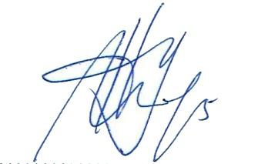
Has been approved by Advisor, Reader, and Head of English language and culture Department to be tested in front of the Board of Examiners of August 9th 2018 at the English Language and Culture Department the Faculty of Humanities, Darma Persada University.

Advisor : . . . . . . . . . . . . . . . . . . . . . . . . .
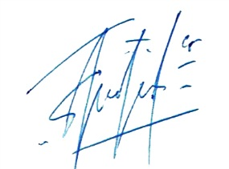
Dra. Eka Yuniar, SS, M,Si

Reader : . . . . . . . . . . . . . . . . . . . . . . . . .
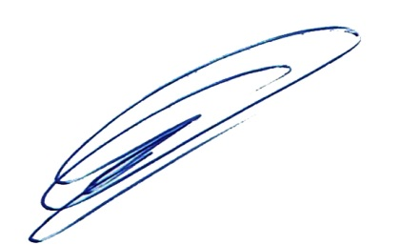
Yoga Pratama, SS, M.Pd

Head of English Language : ……………………………….
and Culture Department Tommy Andrian, SS, M.Hum

APPROVAL PAGE
The term paper has been tested in an opened session on August 9th 2018
By
BOARD OF EXAMINERS
Consisting of :

Advisor : . . . . . . . . . . . . . . . . . . . . . . . .
Eka Yuniar, SS, M.Si

Reader : . . . . . . . . . . . . . . . . . . . . . . . .
Yoga Pratama, SS, M.Pd

Chief of board Examiners : . . . . . . . . . . . . . . . . . . . . . . . .
Tommy Andrian, SS, M.Hum

Approved on August 15th 2018
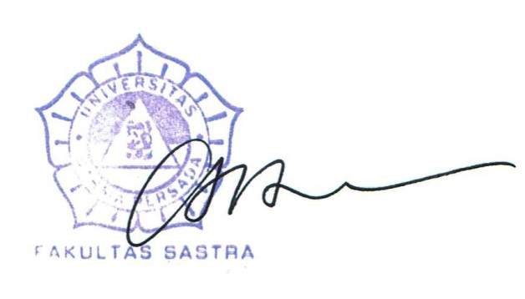
Head of English Language and Dean of Faculty of Humanities
Culture Department

Tommy Andrian, SS, M.Hum Dr.Ir. Eko Cahyono, M, Eng

ACKNOWLEDGEMENT
Praise be to Jesus Christ for His mercy and blessing, finally I could complete this term-paper well, which entitled The Reflection of Robert J. Stenberg the Triangular Theory of Love in Daniel Steel’s Novel Against All Odds.
This term-paper is submitted to the Strata One English Department of University of Darma Persada as a partial fulfillment of the requirements for obtaining the Strata One (S-1) degree.
I would like to thank to all parties who have guided and supported me in finishing this term-paper, my appreciation is delivered to those who give contribution in completion of this term-paper, which I listed as follows:
- Eka Yuniar, SS, M.Si as the Advisor who has guided and helped me patiently in the preparation of this research.
- Yoga Pratama, SS, M.Pd as the Reader who has checked and corrected the word by word thoroughly in this term-paper.
- Tommy Andrian, SS, M.Hum as the Head of English Department.
- Dra. Widiastuti, MA as my Academic Adviser who has guided and helped me patiently in the preparation of my study every semester.
- All lecturers of English Department who have given me so much knowledge and experiences.
- My dear family, my mother and my daddy. whose endless support and love me, who never gives up to make her children get higher education, then is never tired to remind me to always pray and complete my term paper.
- My sister Yohana Olivia Siagian, My brother Yolanda Endro Siagian
- Friansa Sabam Maruli Gultom, who always makes me laugh and support me to finish this term paper.

- My precious friends, Arum, Airin, Inggit, Icha, and all my clasmates, who always color my days and give me many advices, as well as the rest of my classmates in English Department class of 2014 who always support me.

Jakarta, June 21, 2018
Writer

Herlina Eva Siagian

ABSTRACT

Name : Herlina Eva Siagian
Program of Study : English Language and Culture / Strata One (S1) Degree
Title : The Reflection of Robert J. Stenberg the Triangular Theory of Love on Justin’s Character Daniel Steel’s Novel Against All Odds
This term-paper discusses about the theme of a novel. Two approaches, intrinsic and extrinsic approaches, are applied to analyze this novel. The concepts that is applied to analyze through intrinsic approach consists of characterization by using showing and telling methods, plot and setting. The concept to analyze through extrinsic approach is the triangular theory of love by Robert J, Stenberg. This research explains about the reflection of Robert J, Stenberg theory in two characters, Justin and Richard, as well as its relation to other intrinsic elements. In this research,Against All Odds novel is the primary sources and supported by some of relevant theories, concepts, and definitions which as secondary sources.
Keywords: Against all odds,Daniel Steel, triangular theory, Robert J, Stenberg
ABSTRAK

Nama : Herlina Eva Siagian
Program Studi : Bahasa dan Kebudayaan Inggris/ Strata 1
Judul : The Reflection of Robert J. Stenberg the Triangular Theory of Love on Justin’s Character Daniel Steel’s Novel Against All Odds
Skripsi ini membahas tema sebuah novel. Dua pendekatan, pendekatan intrinsik dan ekstrinsik, digunakan untuk menganalisis novel ini. Konsep-konsep yang digunakan untuk menganalisis melalui pendekatan intrinsik meliputi karakterisasi melalui metode langsung dan tidak langsung, alur dan latar. Konsep untuk menganalisis melalui pendekatan ekstrinsik adalah teori cinta yaitu segitiga cinta dari Robert J, Stenberg dan LGBT Identity Development dari Anthony D’Augelli. Penelitian ini membahas menganalisis tentang latar belakang terbentuknya karakter gay dalam sebuah keluarga serta hubungan percintaan terhadap hubungan gay dalam teori segitiga cinta oleh Robert J, Stenberg dalam tokoh Justin. Novel Against All Odds merupakan sumber primer dalam skripsi ini dan didiukung oleh teori-teori, konsep dan definisi terkait yang menjadi sumber sekunder.

TABLE OF CONTENT
INTELLECTUAL PROPERTY STATEMENT PAGE…… iii
TEST FEASIBILITY APPROVAL PAGE………………… iv
APPROVAL PAGE………………………………………….. v
ACKNOWLEDGEMENT…………………………………... vi
ABSTRACT…………………………………………………... vii
TABLE OF CONTENT……………………………………… ix
CHAPTER I : INTRODUCTION…………………………... 1
A. Background of the Research………………………...... 2
B. Identification of Problem……………………………. 2
C. The limitation of Problem………………………….... 2
D. The Formulation of Problem………………………… 3
E. The Objectives of the Research……………………… 3
F. Method of the Research…………………………...... 4
G. Benefit of the Research……………………………… 4
H. Systematic Organization…………………………...... 4
CHAPTER II : FRAMEWORK OF THEORIES
- INTRINSIC APPROACHES
1. Characterization……………………………………… 5
2. Plot…………………………………………………… 8
3. Setting………………………………………………... 9
B. EXTRINSIC APPROACHES
1. Psychology in Literature……………………………... 12
2. Triangular theory of love…………………………...... 13
3. LGBT Identity Development theory…………………. 14
CHAPTER III : AGAINST ALL ODDS THROUGH
INTRINSIC APPROACH
- CHARACTERIZATION
- Kate Wilson……………………………………………………. 17
- Justin…………………………………………………………… 23
- Richard………………………………………………………… 29
4. Julia…………………………………………………................. 36
- Plot
- Exposition……………………………………………………. 41
- Complication………………………………………................. 43
- Crisis………………………………………………................. 44
- Falling Action………………………………………………… 46
- Revolution……………………………………….................... 47
- Setting
- Setting as Background of action…………………………….. 48
- Setting as an atmosphere…………………………………….. 49
- Setting as reveling theme……………………………………... 50
- Setting as an anthagonist……………………………................. 50
- Setting as a revealing character……………………………... 51
CHAPTER IV : AGAINST ALL ODDS THROUGH D’AUGELLI LGBT IDENTITY DEVELOPMENT THEORY AND ROBERT J. STENBERG TRIANGULAR THEORY OF LOVE
1. Analysis Anthonny D’Augelli LGBT Identity Development Theory on in novel Against all odds………………………………………… 52
- The analysis of Gay in LGBT Identity
Development Theory………………………………………… 52
- The analysis og Gay in LGBT Identity
Development through Characterization……………………… 53
- The analysis of Gay in LGBT Identity
Development Through the plot………………………………. 55
- The nalysis of Gay in LGBT Identity
Development Through the setting……………….................... 60
- The analysis LGBT Identity Development
Theory in novel Against All Odds…………………………... 63
2. ANALYSIS TRIANGULAR THEORY OF LOVE ROBERT J. STENBERG…………………………………. 65
1. Passion…………………………………………………………. 53
2. Intimacy…………………………………………….................. 54
3. Commitment………………………………………................... 54
CHAPTER V
CONCLUSION………………………………………………….. 69
REFERENCES…………………………………………………... 70
SCHEME OF THE RESEARCH ……………………………….. 71
RESERCH POSTER…………………………………………….. 72
CURRICULUM VITAE…………………………………………. 73
ATTACHMENT

