SCHEME OF THE RESEARCH

THE REFLECTION OF KASHDAN’S DIMENSION OF CURIOSITY ON CHARACTER OF JANE CAVENDISH IN JP DELANEY’S NOVEL THE GIRL BEFORE

INTRINSIC APPROACHES
EXTRINSIC APPROACHES
Characterization
Setting
Psychology of literature
Plot
- Setting as Background for Action
- Setting as Antagonist
- Setting as A Means of Creating Appropriate Atmosphere
- Setting as A Means of Revealing Character
- Setting as A Means of Reinforcing Theme
- Exposition
- Complication
- Crisis
- Falling Action
- Resolution
- Showing Method:
- Characterization through Dialogue
- Characterization through Action
- Telling Method:
- Characterization through the use of names
- Characterization through Appearance
- Characterization by the Author

Concepts:
- Dimension
of Curiosity
- Joyous Exploration
- Deprivation Sensitivity
- Stress Tolerance
- Social Curiosity
- Thrill Seeking

THE REFLECTION OF KASHDAN’S DIMENSION OF CURIOSITY ON CHARACTER OF JANE CAVENDISH IN JP DELANEY’S NOVEL THE GIRL BEFORE

ANNISA RIZKIAH | 2016130904 |
DEPARTMENT OF LITERATURE | DARMA PERSADA
UNIVERSITY | ansarzkh23@gmail.com |

RESULT OF THE RESEARCH
This research can give us something that we can learn in our lives. As suggestion, by understanding the characterization and psychology that exist in this term paper easily the readers can see the theme of this research. This research is useful to enrich personality psychology since there is only lack sources, which discuss about the Dimension of Curiosity.
SUMMARY
As explained of all methods that I use, it is proven the theme of this research is Dimension of Curiosity on character Jane Cavendish in JP Delaney’s The Girl Before novel.
DISCUSSION
In this research, we learn about something that we do not know before. Curiosity has many positive benefits for our lives. The urge to explore and seek knowledge about our constantly changing environment, which may be why our brains evolved to release dopamine and other feel-good chemicals when we encounter new things. Do not be afraid or shy to ask question and seek answers. Show your interest and desire to acquire knowledge and understanding. This will make your life more interesting, exciting, and fulfilling.

METHODS OF THE RESEARCH
To analyze this research, I use qualitative methods. The qualitative method can be used to analyze the literature by using psychological approaches. I use intrinsic approach such as characterization, plot and setting. Then, Extrinsic approach is Dimension of Curiosity.
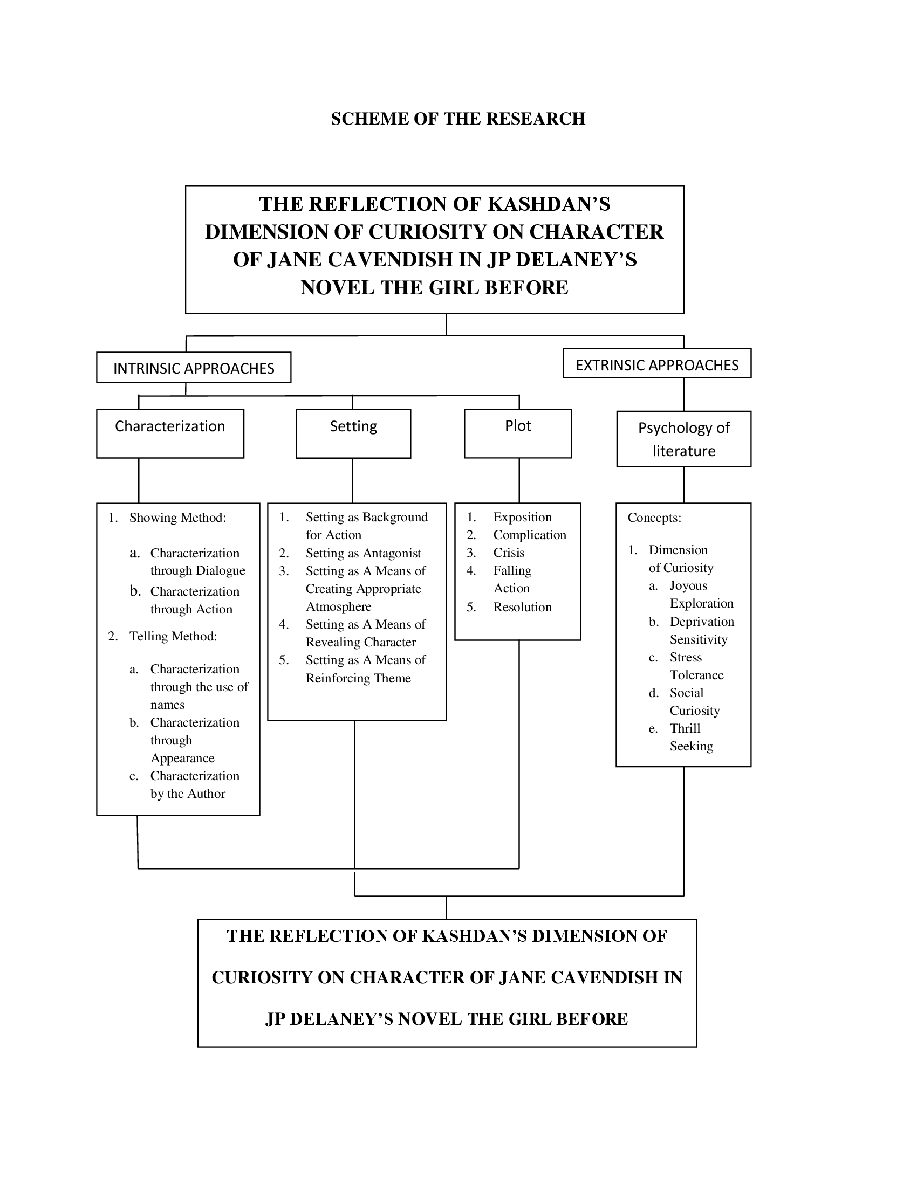

BACKGROUND
Jane Cavendish, a grief-stricken by the stillbirth of her daughter who take up the magnificent house One Folgate Street in London designed by Edward Monkford. But she find herself drawn to house’s creator and its tragic history. Therefore, I want to analyze Jane’s character that experiences dimension of curiosity.
THE REFLECTION OF KASHDAN’S DIMENSION OF CURIOSITY ON CHARACTER OF JANE CAVENDISH IN JP DELANEY’S NOVEL THE GIRL BEFORE

Curriculum Vitae
PERSONAL DATA
Name : Annisa Rizkiah
Nationality : Indonesian
Sex : Female
Place/Date of Birth : Jakarta, October 23, 1995
Address : Taman Wisma Asri. Jl. Markisa 1
Bloc C 17 no. 4 RT 005 RW 007
Kecamatan Teluk Pucung
Bekasi Utara
Phone/Fax : 082242659617
E-mail : ansarzkh23@gmail.com

FORMAL EDUCATION
- 2001 – 2006 : SDIT Al- Manar Bekasi
- 2006 – 2010 : SMPIT Muhammadiyah 28 Bekasi
- 2010 – 2013 : SMAN 92 Jakarta
- 2013 – 2016 : (D3) English Diploma Program at Jendral Soedirman University
- 2016 – now : (S1) English Literature at Darma Persada University

RESEARCH EXPERIENCES
- 2016 : Translated and Analyzed of Short Story by Kay Sextopn’s Starving Makes It Fat
- 2016 : Religion of Australia Institution in 1981 to now
- 2016 : The Analysis of Poem “Richard Cory” by Edwin Arlington Robinson in Realism Era
- 2016 : Walt Whitman Biography
- 2016 : Analysis The Bride Comes to Yellow Sky by Stephen Crane
- 2017 : American Value: The History of Sleves in the United States by Harriet Beecher Stowe
- 2017 : Feminism Through Edna Pontelir in The Awakening by Kate Chopin
- 2017 : Halusinasi Penglihatan Berakibat Naluri Kematian dari cerpen Starving Makes It Fat karya Kay Sexton
- 2017 : The Chasing of American Dream: When It Comes To Mid-Life Crisis
- 2017 : Analysis of Mental Illnes in Short Story of The Deppresed Person by David Foster Wallace
- 2017 : The Symbolism as Reflected In Bride Comes to Yellow Sky by Stephen Crane

WORK EXPERIENCES
- 2017 : Teaching English in Elementary School in TPQ ADNIYAH
- 2017 : Teaching English in SMKIT CITRA BANGSA
- 2017 : Private Teacher
- 2018 : Teaching English in GAMANUSA

