ENGLISH-INDONESIAN ANNOTATED TRANSLATION ON NICOLA YOON’S NOVEL THE SUN IS ALSO A STAR

TERM PAPER

SITI ASROFIYAH

2014130011

STRATA ONE (S-1) OF ENGLISH LANGUAGE AND CULTURE DEPARTMENT

FACULTY OF HUMANITIES
UNIVERSITY OF DARMA PERSADA
JAKARTA
2018

ENGLISH-INDONESIAN ANNOTATED TRANSLATION ON NICOLA YOON’S NOVEL THE SUN IS ALSO A STAR

TERM PAPER

Submitted as Partial Fulfillment of the Requirements
For Obtaining Strata-1 Degree

SITI ASROFIYAH

2014130011

STRATA ONE (S-1) OF ENGLISH LANGUAGE AND CULTURE DEPARTMENT

FACULTY OF HUMANITIES
UNIVERSITY OF DARMA PERSADA
JAKARTA
2018

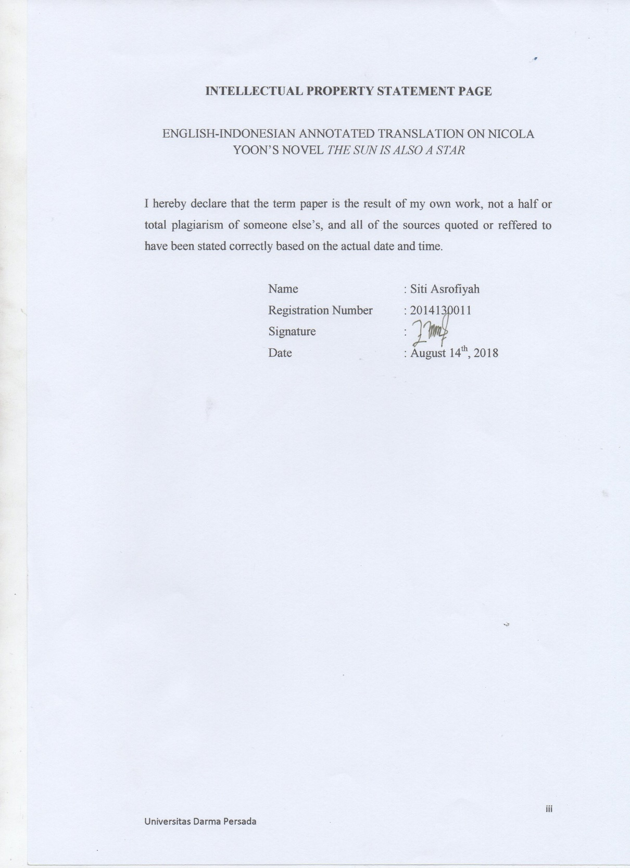

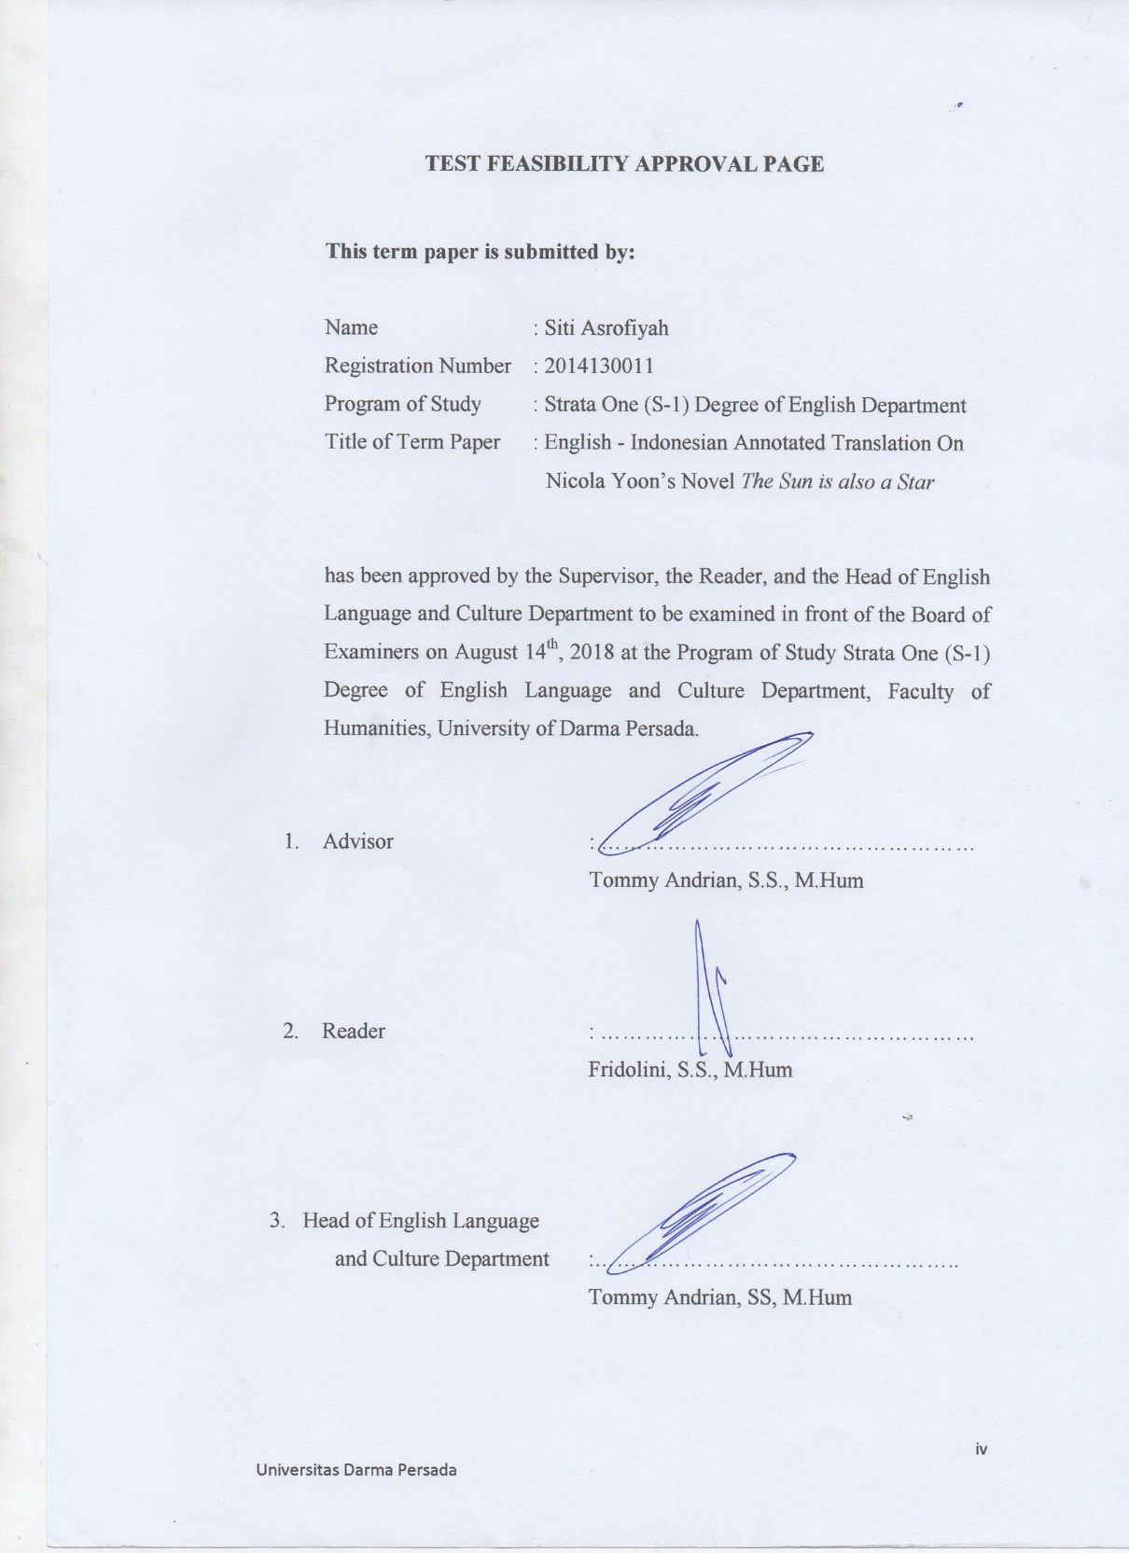

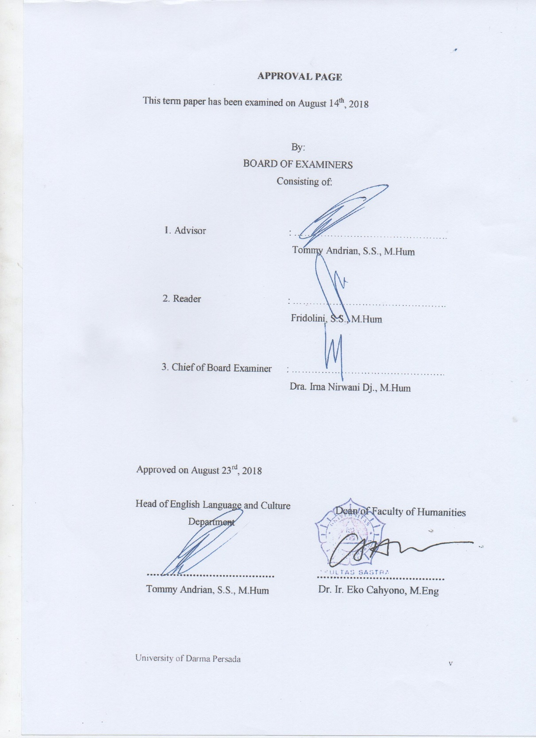

ACKNOWLEDGEMENT

In the name of Allah, the Most Gracious and the Most Merciful.
Praise be upon God, The Cherisher and Sustainer of the worlds. The writer would like to express self gratitude to Allah SWT, for the inspiration and the smoothness in completing this term paper. During the process of arranging and accomplishing this term paper entitled: English-Indonesian Annotated Translation on Nicola Yoon’s Novel The Sun is also a Star, the writer owes many persons. The writer would like to convey the deepest and honest thanks to the below persons:
- My first term paper supervisor, and my academic advisor, Mr. Tommy Andrian, S.S, M. Hum, for the valuable time to give me advice, and direction for this term paper arrangement.
- My second supervisor or the reader, Mrs. Fridolini S.S., M. Hum, for his patiently to give me correction, attention, and support during arranging until accomplishing this term paper.
- Mr. Tommy Andrian, S.S., M. Hum as the head of English department and as the very understanding academic advisor who guides and advices me patiently.
- Dr. Ir. Eko Cahyono, M.Eng as the Dean of Faculty of Humanity.
- My mother Muhinatun, my father Suparno for the endless spirit, motivation, support and pray.
- Dr. H. Dadang Solikin, SE, MA, Rector University of Darma Persada who has given me valuable opportunity to continue my study at this university.
- All great lecturers at University of Darma Persada, Mr. Tommy Andrian, S.S, M.Hum, Mr. Juliansyah, S.Pd, M.Pd, Mrs. Eka Yuniar, S.S, M.Si, Mrs. Fridolini, S.S, M.Hum, Mr. Yoga Pratama, S.S, M.Pd, Mr. Agustinus Haryana, S.S, Mr. Rhenatus Alfonsus Beresaby, SE, M.Hum, Mr. Rusydi M. Yusuf. MSi and other lecturers who have given me much inspiration, experience, precious lessons and valuable knowledge during study.

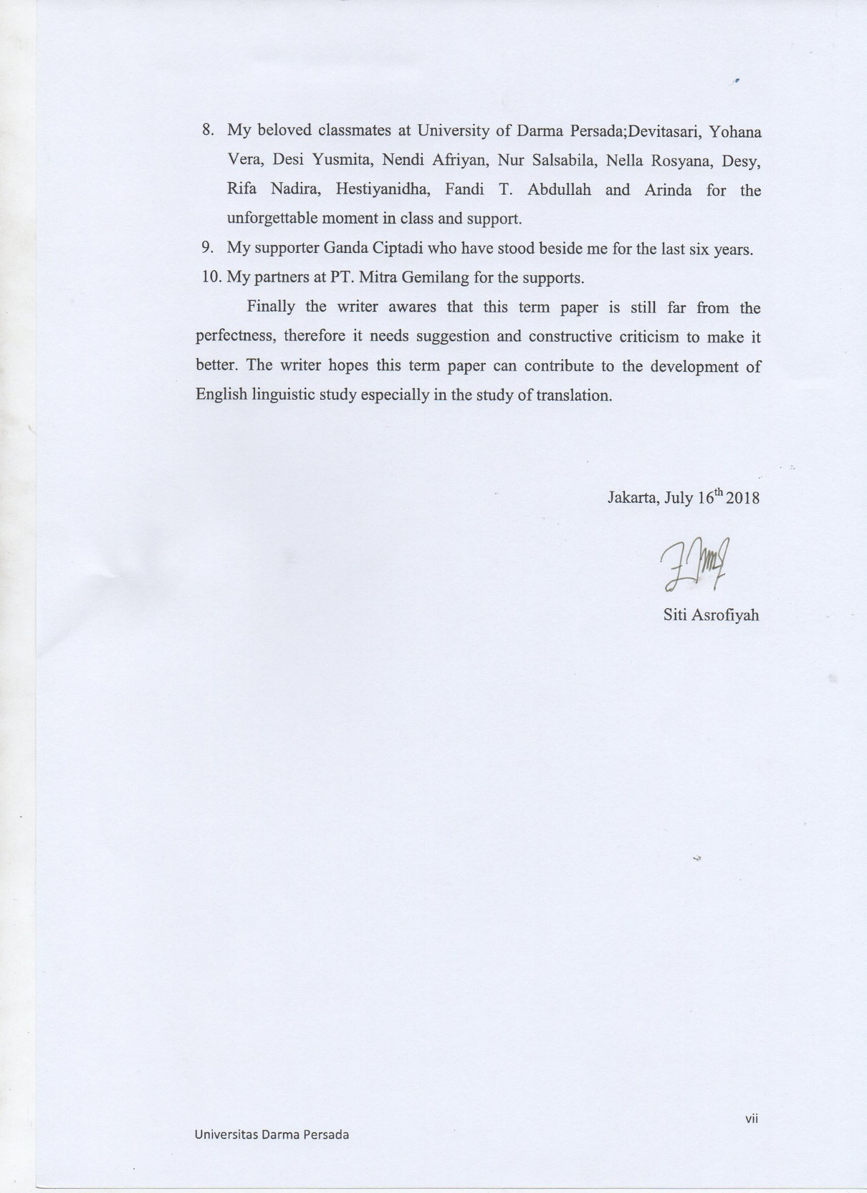
ABSTRAK

Nama : Siti Asrofiyah
Program Studi : Sastra Inggris (S1)
Judul : English-Indonesian Annotated Translation on
NicolaYoon’s Novel The Sun Is Also A Star

Terjemahan beranotasi terdiri dari dua fase, yaitu terjemahan dan anotasi.Terjemahan digunakan untuk menterjemahkan suatu karya dari teks sumber kedalam teks sasaran.Sedangkan anotasi digunakan untuk memberikan penjelasan tambahan suatu kata atau kalimat yang menimbulkan masalah penerjemahan. Terjemahan beranotasi bertujuan untuk memberikan pertanggungjawaban atas padanan yang penulis pilih dalam menerjemahkan novel The Sun is also a Star. Dalam proses penerjemahan, penulis menggunakan beberapa metode dan prosedur, di antaranya adalah amplifikasi, padanan budaya, idiomatis, deskriptif, kata demi kata, komunikatif dan peminjaman. Penulis menemukan beberapa kesulitan dalam proses penerjemahan, seperti menerjemahkan langgam bahasa dan mencari padanan kata.Ada 44 anotasi yang mencakup kata-kata, frasa, idiom, dan kalimat yang sulit diterjemahkan kedalam bahasa Indonesia, dan juga membutuhkan penjelasan tambahan.

Kata kunci: terjemahan, anotasi, novel

ABSTRACT

Name : Siti Asrofiyah
Program of Study : Strata One (S1)
Title : English-Indonesian Annotated Translation on
NicolaYoon’s Novel The Sun Is Also A Star

Annotated translation consist of two phases, they are annotation and translation. Translation is used to translate a work from source text into target text. While annotation is used to give additional information of words or sentences that cause translation problem. Annotated translation aims to provide responsibility to the equivalent that the writer chose in translating The Sun is also a Star. In the process of translation, the writer uses many methods and procedurs, as amplification, cultural equivalent, idiomatic, descriptive, word-for-word, communicative, and borrowing. The writer finds some difficulties in the process of translation, as translate the idiom, and find the equivalent words. There are 44 annotations which cover words, phrasa, idioms, and sentences which have difficulty to be translated into Indonesian language, and also need addiotional explanations.

Keywords: translation, annotation, novel

TABLE OF CONTENTS

INTELLECTUAL PROPERTY STATEMENT PAGE iii
TEST FEASIBILITY APPROVAL PAGE iv
APPROVAL PAGE v
ACKNOWLEDGMENT vi
ABSTRAK viii
ABSTRACT ix
TABLE OF CONTENTS x
LIST OF PICTURES xiii
LIST OF TABLES xiv

CHAPTER 1: INTRODUCTION
1.1 Background of the Research 1
1.2Identification of the Problem 2
1.3 Limitation of the Problem 2
1.4 Formulation of the Problem 2
1.5 Objectives of the Research 2
1.6 Methods of the Research 3
1.7 Benefits of the Research 3
1.8 Systematic Organization of the Research 3

CHAPTER 2: FRAMEWORK OF THEORIES
2.1 Definition of Translation 5
2.2 Methods of Translation 9
2.2.1 Word-for-word Translation 9

2.2.2 Literal Translation 9

2.2.3 Faithful Translation 10

2.2.4 Semantic Translation 10

2.2.5 Adaptation 11

2.2.6 Free Translation 11

2.2.7 Idiomatic Translation 11

2.2.8 Communicative Translation 12

2.3 The Procedures of Translation 12

2.3.1 Borrowing 12

2.3.2 Cultural Equivalent 13

2.3.3 Shift or Transposition 13

2.3.4 Paraphrase 13

2.3.5 Modulation 13

2.3.6 Descriptive 14

2.3.7 Calque 14

2.3.8 Modulation 14

CHAPTER 3: ENGLISH-INDONESIAN ANNOTATED TRANSLATION IN NICOLA YOON’S NOVEL THE SUN IS ALSO A STAR
3.1 Annotation 15
3.1.1 Idiomatic Translation Method 15
3.1.2 Culltural Equivalent Translation Procedure 24
3.1.3 Word-for-word Translation Method 31
3.1.4 Communicative Translation Method 34
3.1.5 Amplification Translation Procedure 36
3.1.6 Descriptive Translation Procedure 49
3.1.7 Borrowing Translation Procedure 55

CHAPTER 4: CONCLUSION
4.1 Conclusion 57
BIBLIOGRAPHY 58
SCHEME OF THE RESEARCH 60
POSTER RESEARCH 61
ABOUT THE WRITER 62
LIST OF PICTURES

Picture 1 : Newmark’s flattened V diagram 6
Picture 2 : Sandwich Board 31
Picture 3 : Mandu 41
Picture 4 : Afro hairstyle 43
Picture 5: Soon Dubu 45
Picture 6: Kalbi 46
Picture 7: Pa Jun 47
Picture 8:Kimchi 48
Picture 9: Sauerkraut 54
Picture 10:Crumpets 56
Picture 11: Chaps 57

LIST OF TABLES

Table 1:The Annotation of don’t let you pride get the better of you 16
Table 2 :The Annotation of I put my foot down 16
Table 3 : The Annotation of epic douche bag, an animatronic dick complete
with ball sac 17
Table 4 : The Annotation of Big-ass 18
Table 5 : The Annotation of Strength in number and Jesus Christ
bleeding on a popsicle stick 19
Table 6 : The annotation of That ship has sailed 21
Table 7 :The Annotation of Down on my luck 22
Table 8 :The annotation of To the virgins, to make much time 23
Table 9 : The Annotation of booger 24
Table 10: The Annotation of Pain in the ass and language 25
Table 11: The annotation of irie 27
Table 12: The Annotation of Aigo 28
Table 13: The Annotation of unit measure 29
Table 14: The Annotation of Touche 29
Table 15: The Annotation of Sandwich Board 30
Table 16: The Annotation of Open Sesame 33
Table 17: The Annotation of Annyeonghaseyo 34
Table 18: The Annotation of DUI 35
Table 19: The Annotation of HVAC 36
Table 20: The Annotation of Sexy-pouting 37
Table 21: The Annotation of Dire Odds 38
Table 22: The Annotation of Bob Marley’s song 39
Table 23: The annotation of Yale alum 40
Table 24: The Annotation of Mandu 41
Table 25: The Annotation of Lord of the Flies’s Novel 42
Table 26: The annotation of Afro 43
Table 27: The Annotation of New York Times 44
Table 28: The annotation of soon dubu 44
Table 29: The Annotation of Kalbi and Pa Jun 45
Table 30: The annotation of Kimchi 47
Table 31: The Annotation of Cricket 48
Table 32: The Annotation of Davied Copperfield’s Novel 48
Table 33: The Annotation of Do-Card Over 50
Table 34: The annotation of MIT 51
Table 35: The Annotation of USCIS 52
Table 36: The Annotation of Sauerkraut 53
Table 37: The Annotation of OCD 54
Table 38: The Annotation of Crumpets 54
Table 39: The Annotation of Chaps 55
Table 40: The Annotation of Flash mob 57

